Default Report  
*Latinx Youth Vaping Project- English In Person Study Survey*  
**November 8th 2019, 9:28 am MST**

**Q115 - Study ID**

|  |
| --- |
| Study ID |
| 121 |
| 120 |
| 119 |
| 118 |
| 117 |
| 116 |
| 115 |
| 114 |
| 113 |
| 112 |
| 111 |
| 110 |
| 109 |
| 108 |
| 107 |
| 105 |
| 104 |
| 103 |
| 102 |
| 101 |
| 100 |

**Q116 - Today's date**

|  |
| --- |
| Today's date |
| 10/04/2019 |
| 10/04/2019 |
| 10/04/2019 |
| 10/04/2019 |
| 10/04/2019 |
| 10/04/2019 |
| 10/04/2019 |
| 10/04/2019 |
| 10/04/2019 |
| 10/04/2019 |
| 10/04/2019 |
| 10/04/2019 |
| 10/04/2019 |
| 10/04/2019 |
| 09/06/2019 |
| 9/6/2019 |
| 9/6/2019 |
| 9/6/2019 |
| 9/6/2019 |
| 9/6/2019 |
| 9/6/2019 |

**Q1 - What is the name of the city where you live?**

|  |
| --- |
| What is the name of the city where you live? |
| Pueblo |
| Pueblo |
| Pueblo |
| Pueblo |
| Pueblo |
| Pueblo |
| Pueblo |
| Pueblo |
| Pueblo |
| Pueblo |
| Pueblo |
| Pueblo |
| Avondale |
| Pueblo |
| Pueblo |
| Pueblo |
| Pueblo |
| Pueblo |
| Pueblo |
| Pueblo |

**Q2 - How old are you?**

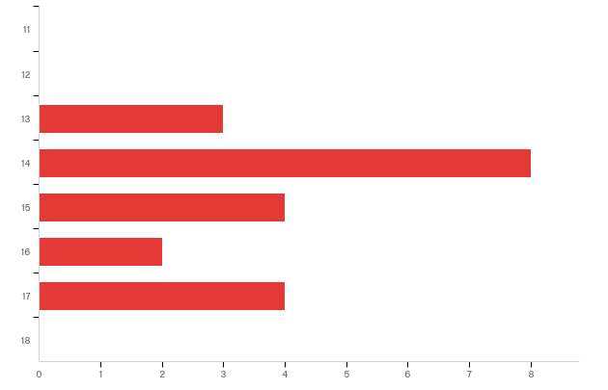

|  |  |  |  |  |  |  |  |
| --- | --- | --- | --- | --- | --- | --- | --- |
| # | Field | Minimum | Maximum | Mean | Std Deviation | Variance | Count |
| 1 | How old are you? | 6.00 | 10.00 | 7.81 | 1.33 | 1.77 | 21 |

|  |  |  |  |
| --- | --- | --- | --- |
| # | Answer | % | Count |
| 4 | 11 | 0.00% | 0 |
| 5 | 12 | 0.00% | 0 |
| 6 | 13 | 14.29% | 3 |
| 7 | 14 | 38.10% | 8 |
| 8 | 15 | 19.05% | 4 |
| 9 | 16 | 9.52% | 2 |
| 10 | 17 | 19.05% | 4 |
| 11 | 18 | 0.00% | 0 |
|  | Total | 100% | 21 |

**Q3 - What is your sex?**

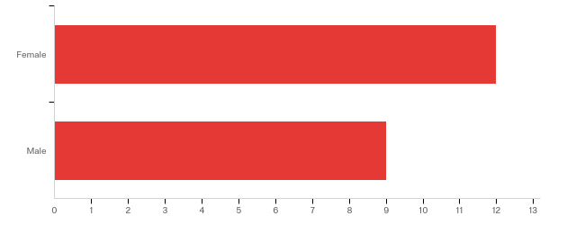

|  |  |  |  |  |  |  |  |
| --- | --- | --- | --- | --- | --- | --- | --- |
| # | Field | Minimum | Maximum | Mean | Std Deviation | Variance | Count |
| 1 | What is your sex? | 1.00 | 2.00 | 1.43 | 0.49 | 0.24 | 21 |

|  |  |  |  |
| --- | --- | --- | --- |
| # | Answer | % | Count |
| 1 | Female | 57.14% | 12 |
| 2 | Male | 42.86% | 9 |
|  | Total | 100% | 21 |

**Q4 - Which of the following best describes you?**

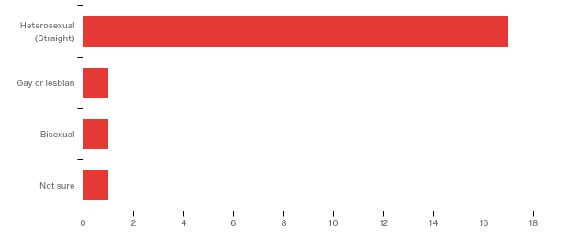

|  |  |  |  |  |  |  |  |
| --- | --- | --- | --- | --- | --- | --- | --- |
| # | Field | Minimum | Maximum | Mean | Std Deviation | Variance | Count |
| 1 | Which of the following best describes you? | 1.00 | 6.00 | 1.40 | 1.16 | 1.34 | 20 |

|  |  |  |  |
| --- | --- | --- | --- |
| # | Answer | % | Count |
| 1 | Heterosexual (Straight) | 85.00% | 17 |
| 2 | Gay or lesbian | 5.00% | 1 |
| 3 | Bisexual | 5.00% | 1 |
| 6 | Not sure | 5.00% | 1 |
|  | Total | 100% | 20 |

**Q5 - Some people describe themselves as transgender when their sex at birth does not match the way they think or feel about their gender. Are you transgender?**

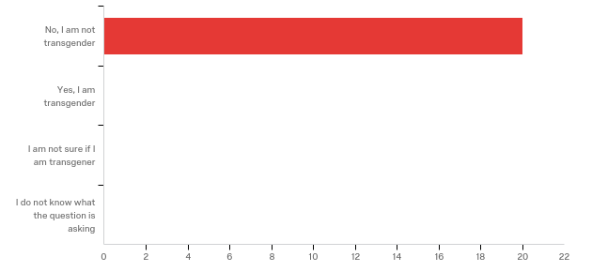

|  |  |  |  |  |  |  |  |
| --- | --- | --- | --- | --- | --- | --- | --- |
| # | Field | Minimum | Maximum | Mean | Std Deviation | Variance | Count |
| 1 | Some people describe themselves as transgender when their sex at birth does not match the way they think or feel about their gender. Are you transgender? | 1.00 | 1.00 | 1.00 | 0.00 | 0.00 | 20 |

|  |  |  |  |
| --- | --- | --- | --- |
| # | Answer | % | Count |
| 1 | No, I am not transgender | 100.00% | 20 |
| 2 | Yes, I am transgender | 0.00% | 0 |
| 3 | I am not sure if I am transgener | 0.00% | 0 |
| 4 | I do not know what the question is asking | 0.00% | 0 |
|  | Total | 100% | 20 |

**Q6 - What grade are you in?**

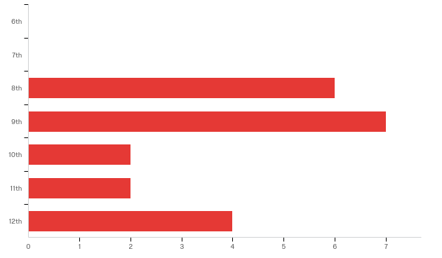

|  |  |  |  |  |  |  |  |
| --- | --- | --- | --- | --- | --- | --- | --- |
| # | Field | Minimum | Maximum | Mean | Std Deviation | Variance | Count |
| 1 | What grade are you in? | 3.00 | 7.00 | 4.57 | 1.47 | 2.15 | 21 |

|  |  |  |  |
| --- | --- | --- | --- |
| # | Answer | % | Count |
| 1 | 6th | 0.00% | 0 |
| 2 | 7th | 0.00% | 0 |
| 3 | 8th | 28.57% | 6 |
| 4 | 9th | 33.33% | 7 |
| 5 | 10th | 9.52% | 2 |
| 6 | 11th | 9.52% | 2 |
| 7 | 12th | 19.05% | 4 |
|  | Total | 100% | 21 |

**Q7 - Are you Hispanic or Latino?**

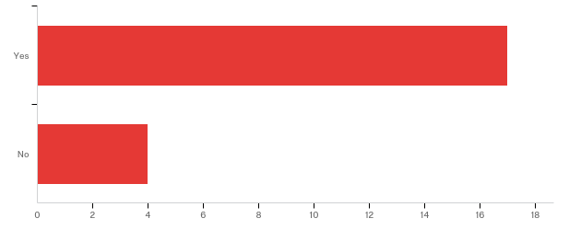

|  |  |  |  |  |  |  |  |
| --- | --- | --- | --- | --- | --- | --- | --- |
| # | Field | Minimum | Maximum | Mean | Std Deviation | Variance | Count |
| 1 | Are you Hispanic or Latino? | 1.00 | 2.00 | 1.19 | 0.39 | 0.15 | 21 |

|  |  |  |  |
| --- | --- | --- | --- |
| # | Answer | % | Count |
| 1 | Yes | 80.95% | 17 |
| 2 | No | 19.05% | 4 |
|  | Total | 100% | 21 |

**Q8 - What is your race? (choose all that apply)**

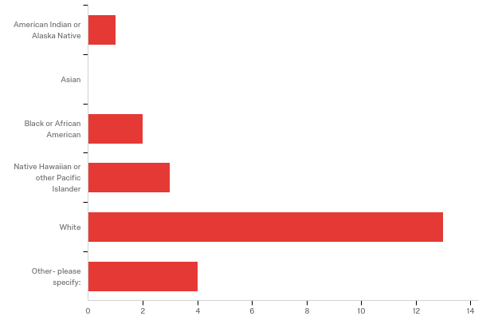

|  |  |  |  |
| --- | --- | --- | --- |
| # | Answer | % | Count |
| 1 | American Indian or Alaska Native | 4.35% | 1 |
| 2 | Asian | 0.00% | 0 |
| 3 | Black or African American | 8.70% | 2 |
| 4 | Native Hawaiian or other Pacific Islander | 13.04% | 3 |
| 5 | White | 56.52% | 13 |
| 7 | Other- please specify: | 17.39% | 4 |
|  | Total | 100% | 23 |

Q8_7_TEXT - Other- please specify:

|  |
| --- |
| Other- please specify: - Text |
| unk |
| unk |
| unk |
| ink |

**Q9 - Do you speak a language other than English at home?**

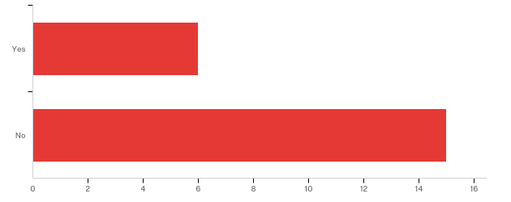

|  |  |  |  |  |  |  |  |
| --- | --- | --- | --- | --- | --- | --- | --- |
| # | Field | Minimum | Maximum | Mean | Std Deviation | Variance | Count |
| 1 | Do you speak a language other than English at home? | 1.00 | 2.00 | 1.71 | 0.45 | 0.20 | 21 |

|  |  |  |  |
| --- | --- | --- | --- |
| # | Answer | % | Count |
| 1 | Yes | 28.57% | 6 |
| 2 | No | 71.43% | 15 |
|  | Total | 100% | 21 |

**Q65 - What other language do you speak at home?**

|  |
| --- |
| What other language do you speak at home? |
| Spanish |
| Spanish |
| Spanish |
| Spanish |
| unk |
| Spanish |

**Q10 - Where were you born?**

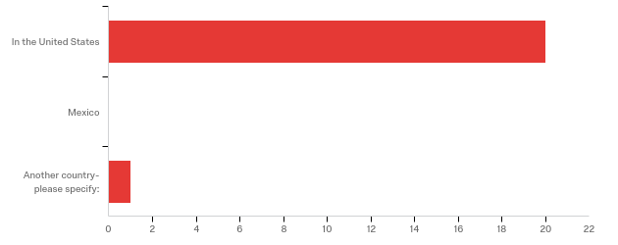

|  |  |  |  |  |  |  |  |
| --- | --- | --- | --- | --- | --- | --- | --- |
| # | Field | Minimum | Maximum | Mean | Std Deviation | Variance | Count |
| 1 | Where were you born? - Selected Choice | 2.00 | 4.00 | 2.10 | 0.43 | 0.18 | 21 |

|  |  |  |  |
| --- | --- | --- | --- |
| # | Answer | % | Count |
| 2 | In the United States | 95.24% | 20 |
| 3 | Mexico | 0.00% | 0 |
| 4 | Another country- please specify: | 4.76% | 1 |
|  | Total | 100% | 21 |

Q10_4_TEXT - Another country- please specify:

|  |
| --- |
| Another country- please specify: - Text |
| Puerto Rico |

**Q11 - How long have you lived in the US (the most recent time if you go back and forth between countries)?**

|  |
| --- |
| How long have you lived in the US (the most recent time if you go back and forth between countries)? |
| 14 |
| 16 |
| 5 |
| 13 |
| 15 |
| 13 |
| 14 |
| 17 |
| 15 |
| 14 |
| 15 |
| 14 |
| 14 |
| 17 |
| 7 |
| 7 |
| 13 |
| 14 |
| 17 |
| 14 |

**Q12 - How well do you speak English?**

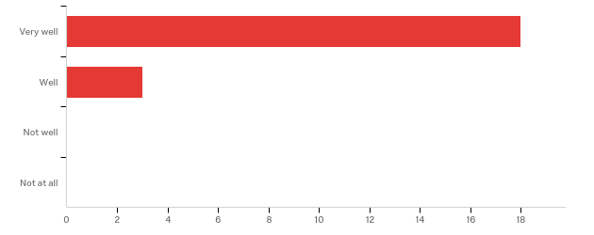

|  |  |  |  |  |  |  |  |
| --- | --- | --- | --- | --- | --- | --- | --- |
| # | Field | Minimum | Maximum | Mean | Std Deviation | Variance | Count |
| 1 | How well do you speak English? | 1.00 | 2.00 | 1.14 | 0.35 | 0.12 | 21 |

|  |  |  |  |
| --- | --- | --- | --- |
| # | Answer | % | Count |
| 1 | Very well | 85.71% | 18 |
| 2 | Well | 14.29% | 3 |
| 3 | Not well | 0.00% | 0 |
| 4 | Not at all | 0.00% | 0 |
|  | Total | 100% | 21 |

**Q66 - Have you ever used any of the following, even just one or two times? (mark the ones you have tried)**

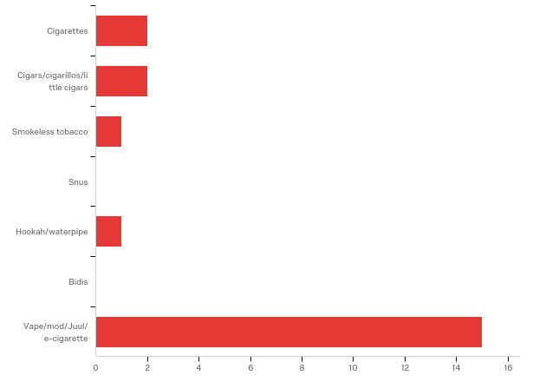

|  |  |  |  |
| --- | --- | --- | --- |
| # | Answer | % | Count |
| 1 | Cigarettes | 9.52% | 2 |
| 2 | Cigars/cigarillos/little cigars | 9.52% | 2 |
| 4 | Smokeless tobacco | 4.76% | 1 |
| 5 | Snus | 0.00% | 0 |
| 6 | Hookah/waterpipe | 4.76% | 1 |
| 7 | Bidis | 0.00% | 0 |
| 8 | Vape/mod/Juul/ e-cigarette | 71.43% | 15 |
|  | Total | 100% | 21 |

**Q14 - How old were you when you first tried a vape device, even one or two times?**

|  |  |  |  |  |  |  |  |
| --- | --- | --- | --- | --- | --- | --- | --- |
| # | Field | Minimum | Maximum | Mean | Std Deviation | Variance | Count |
| 1 | How old were you when you first tried a vape device, even one or two times? | 8.00 | 16.00 | 12.69 | 2.08 | 4.34 | 16 |

**Q117 - How may times have you used a vape or an electronic nicotine product in your entire life?**

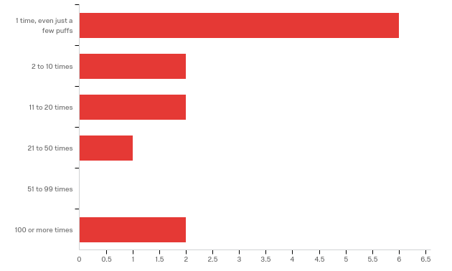

|  |  |  |  |  |  |  |  |
| --- | --- | --- | --- | --- | --- | --- | --- |
| # | Field | Minimum | Maximum | Mean | Std Deviation | Variance | Count |
| 1 | How may times have you used a vape or an electronic nicotine product in your entire life? | 1.00 | 6.00 | 2.46 | 1.78 | 3.17 | 13 |

|  |  |  |  |
| --- | --- | --- | --- |
| # | Answer | % | Count |
| 1 | 1 time, even just a few puffs | 46.15% | 6 |
| 2 | 2 to 10 times | 15.38% | 2 |
| 3 | 11 to 20 times | 15.38% | 2 |
| 4 | 21 to 50 times | 7.69% | 1 |
| 5 | 51 to 99 times | 0.00% | 0 |
| 6 | 100 or more times | 15.38% | 2 |
|  | Total | 100% | 13 |

**Q15 - In the past 30 days, on how many days did you use an vape device?**

|  |  |  |  |  |  |  |  |
| --- | --- | --- | --- | --- | --- | --- | --- |
| # | Field | Minimum | Maximum | Mean | Std Deviation | Variance | Count |
| 1 | In the past 30 days, on how many days did you use an vape device? | 0.00 | 30.00 | 3.69 | 7.77 | 60.37 | 13 |

**Q16 - When was the last time you
used a vape device, even one or two times?**

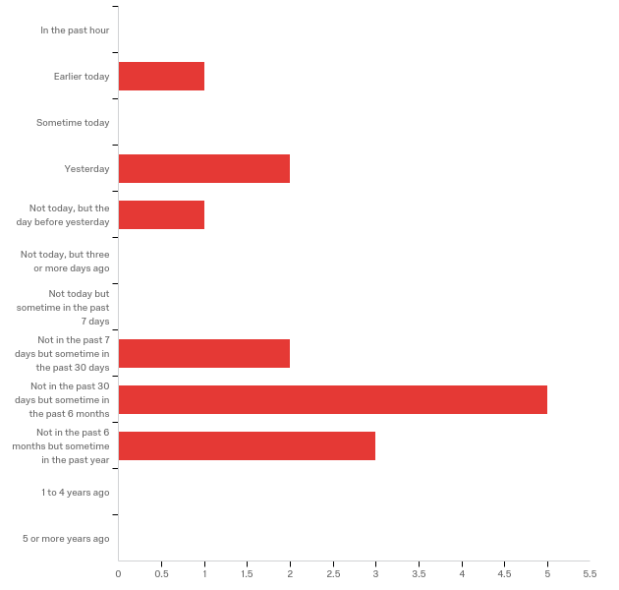

|  |  |  |  |  |  |  |  |
| --- | --- | --- | --- | --- | --- | --- | --- |
| # | Field | Minimum | Maximum | Mean | Std Deviation | Variance | Count |
| 1 | When was the last time you used a vape device, even one or two times? | 1.00 | 12.00 | 5.43 | 3.25 | 10.53 | 14 |

|  |  |  |  |
| --- | --- | --- | --- |
| # | Answer | % | Count |
| 9 | In the past hour | 0.00% | 0 |
| 1 | Earlier today | 7.14% | 1 |
| 10 | Sometime today | 0.00% | 0 |
| 11 | Yesterday | 14.29% | 2 |
| 12 | Not today, but the day before yesterday | 7.14% | 1 |
| 13 | Not today, but three or more days ago | 0.00% | 0 |
| 2 | Not today but sometime in the past 7 days | 0.00% | 0 |
| 3 | Not in the past 7 days but sometime in the past 30 days | 14.29% | 2 |
| 4 | Not in the past 30 days but sometime in the past 6 months | 35.71% | 5 |
| 5 | Not in the past 6 months but sometime in the past year | 21.43% | 3 |
| 6 | 1 to 4 years ago | 0.00% | 0 |
| 7 | 5 or more years ago | 0.00% | 0 |
|  | Total | 100% | 14 |

**Q18 - How many puffs from a vape
device did you have when you last used it?**

|  |  |  |  |  |  |  |  |
| --- | --- | --- | --- | --- | --- | --- | --- |
| # | Field | Minimum | Maximum | Mean | Std Deviation | Variance | Count |
| 1 | How many puffs from a vape device did you have when you last used it? | 1.00 | 12.00 | 4.87 | 2.90 | 8.38 | 15 |

**Q19 - Which
type of vape device(s) do you use most
often? (please mark all that apply)**

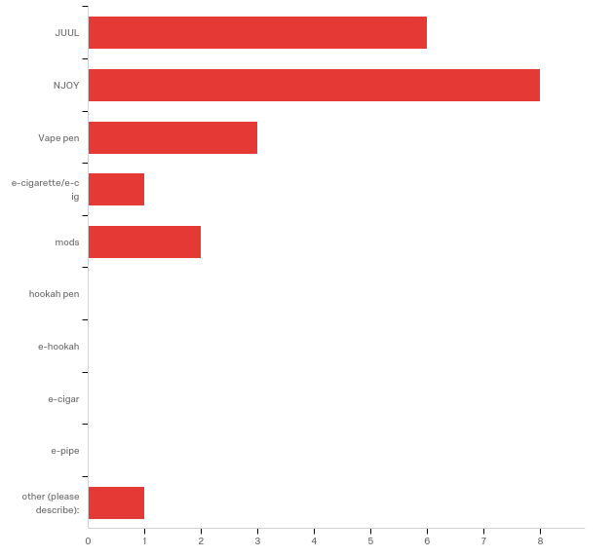

|  |  |  |  |
| --- | --- | --- | --- |
| # | Answer | % | Count |
| 1 | JUUL | 28.57% | 6 |
| 2 | NJOY | 38.10% | 8 |
| 3 | Vape pen | 14.29% | 3 |
| 4 | e-cigarette/e-cig | 4.76% | 1 |
| 5 | mods | 9.52% | 2 |
| 6 | hookah pen | 0.00% | 0 |
| 7 | e-hookah | 0.00% | 0 |
| 8 | e-cigar | 0.00% | 0 |
| 9 | e-pipe | 0.00% | 0 |
| 10 | other (please describe): | 4.76% | 1 |
|  | Total | 100% | 21 |

Q19_10_TEXT - other (please describe):

|  |
| --- |
| other (please describe): - Text |
| Sourin |

**Q20 - Please
answer yes or no to the following questions about the vape device you use most often**

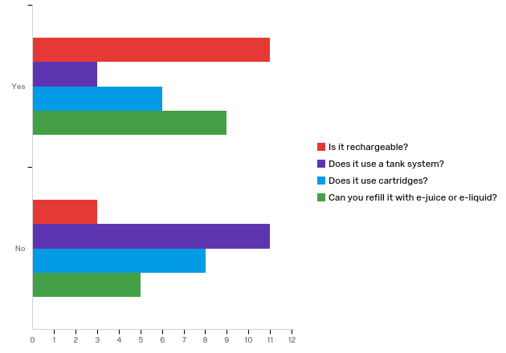

|  |  |  |  |  |  |  |
| --- | --- | --- | --- | --- | --- | --- |
| # | Question | Yes |  | No |  | Total |
| 1 | Is it rechargeable? | 78.57% | 11 | 21.43% | 3 | 14 |
| 2 | Does it use a tank system? | 21.43% | 3 | 78.57% | 11 | 14 |
|  | Does it use cartridges? | 42.86% | 6 | 57.14% | 8 | 14 |
|  | Can you refill it with e-juice or e-liquid? | 64.29% | 9 | 35.71% | 5 | 14 |

**Q21 - How often do you refill
your vape device with e-juice/e-liquid?**

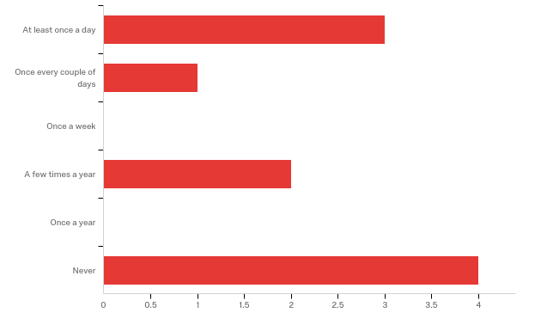

|  |  |  |  |  |  |  |  |
| --- | --- | --- | --- | --- | --- | --- | --- |
| # | Field | Minimum | Maximum | Mean | Std Deviation | Variance | Count |
| 1 | How often do you refill your vape device with e-juice/e-liquid? | 1.00 | 6.00 | 3.70 | 2.15 | 4.61 | 10 |

|  |  |  |  |
| --- | --- | --- | --- |
| # | Answer | % | Count |
| 1 | At least once a day | 30.00% | 3 |
| 2 | Once every couple of days | 10.00% | 1 |
| 3 | Once a week | 0.00% | 0 |
| 4 | A few times a year | 20.00% | 2 |
| 5 | Once a year | 0.00% | 0 |
| 6 | Never | 40.00% | 4 |
|  | Total | 100% | 10 |

**Q22 - Who refills it with e-juice/e-liquid?**

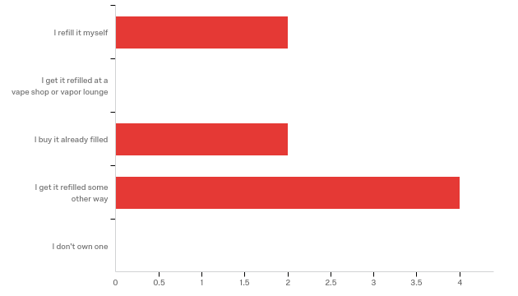

|  |  |  |  |  |  |  |  |
| --- | --- | --- | --- | --- | --- | --- | --- |
| # | Field | Minimum | Maximum | Mean | Std Deviation | Variance | Count |
| 1 | Who refills it with e-juice/e-liquid? | 1.00 | 4.00 | 3.00 | 1.22 | 1.50 | 8 |

|  |  |  |  |
| --- | --- | --- | --- |
| # | Answer | % | Count |
| 1 | I refill it myself | 25.00% | 2 |
| 2 | I get it refilled at a vape shop or vapor lounge | 0.00% | 0 |
| 3 | I buy it already filled | 25.00% | 2 |
| 4 | I get it refilled some other way | 50.00% | 4 |
| 6 | I don't own one | 0.00% | 0 |
|  | Total | 100% | 8 |

**Q74 - Have you ever mixed CBD/THC substances with a vaping
device?**

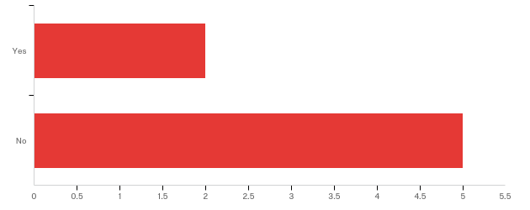

|  |  |  |  |  |  |  |  |
| --- | --- | --- | --- | --- | --- | --- | --- |
| # | Field | Minimum | Maximum | Mean | Std Deviation | Variance | Count |
| 1 | Have you ever mixed CBD/THC substances with a vaping device? | 2.00 | 3.00 | 2.71 | 0.45 | 0.20 | 7 |

|  |  |  |  |
| --- | --- | --- | --- |
| # | Answer | % | Count |
| 2 | Yes | 28.57% | 2 |
| 3 | No | 71.43% | 5 |
|  | Total | 100% | 7 |

**Q75 - Do you know people who have mixed CBD/THC substances with a vaping device?**

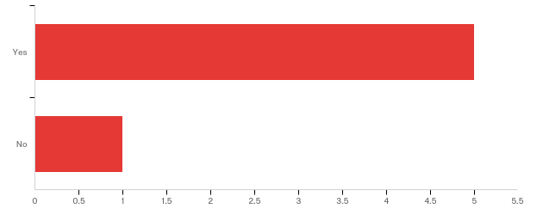

|  |  |  |  |  |  |  |  |
| --- | --- | --- | --- | --- | --- | --- | --- |
| # | Field | Minimum | Maximum | Mean | Std Deviation | Variance | Count |
| 1 | Do you know people who have mixed CBD/THC substances with a vaping device? | 1.00 | 2.00 | 1.17 | 0.37 | 0.14 | 6 |

|  |  |  |  |
| --- | --- | --- | --- |
| # | Answer | % | Count |
| 1 | Yes | 83.33% | 5 |
| 2 | No | 16.67% | 1 |
|  | Total | 100% | 6 |

**Q23 - Please think about the vape devise you use most often. Does it contain nicotine?**

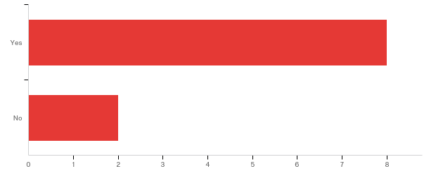

|  |  |  |  |  |  |  |  |
| --- | --- | --- | --- | --- | --- | --- | --- |
| # | Field | Minimum | Maximum | Mean | Std Deviation | Variance | Count |
| 1 | Please think about the vape devise you use most often. Does it contain nicotine? | 1.00 | 2.00 | 1.20 | 0.40 | 0.16 | 10 |

|  |  |  |  |
| --- | --- | --- | --- |
| # | Answer | % | Count |
| 1 | Yes | 80.00% | 8 |
| 2 | No | 20.00% | 2 |
|  | Total | 100% | 10 |

**Q24 - On average, on the days
that you vape, how many times each day do you
pick up your vape device to use it, whether you take one puff or
several?**

|  |  |  |  |  |  |  |  |
| --- | --- | --- | --- | --- | --- | --- | --- |
| # | Field | Minimum | Maximum | Mean | Std Deviation | Variance | Count |
| 1 | On average, on the days that you vape, how many times each day do you pick up your vape device to use it, whether you take one puff or several? | 0.00 | 14.00 | 3.11 | 4.12 | 16.99 | 9 |

**Q25 - Each time you pick up your
vape device, about how many puffs
do you take?**

|  |  |  |  |  |  |  |  |
| --- | --- | --- | --- | --- | --- | --- | --- |
| # | Field | Minimum | Maximum | Mean | Std Deviation | Variance | Count |
| 1 | Each time you pick up your vape device, about how many puffs do you take? | 0.00 | 10.00 | 2.83 | 2.73 | 7.47 | 12 |

**Q26 - Which
strength of e-juice/e-liquid do you usually use? (choose all that apply to you)**

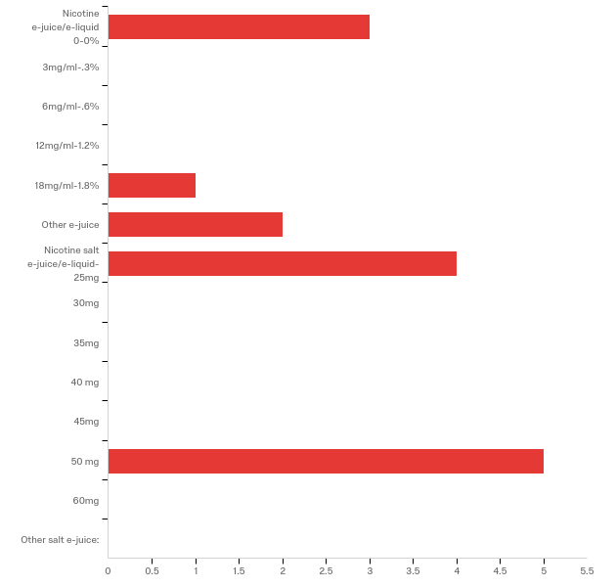

Data source misconfigured for this visualization

|  |  |  |  |
| --- | --- | --- | --- |
| # | Answer | % | Count |
| 1 | Nicotine e-juice/e-liquid 0-0% | 20.00% | 3 |
| 2 | 3mg/ml-.3% | 0.00% | 0 |
| 3 | 6mg/ml-.6% | 0.00% | 0 |
| 4 | 12mg/ml-1.2% | 0.00% | 0 |
| 5 | 18mg/ml-1.8% | 6.67% | 1 |
| 6 | Other e-juice | 13.33% | 2 |
| 9 | Nicotine salt e-juice/e-liquid- 25mg | 26.67% | 4 |
| 10 | 30mg | 0.00% | 0 |
| 11 | 35mg | 0.00% | 0 |
| 12 | 40 mg | 0.00% | 0 |
| 13 | 45mg | 0.00% | 0 |
| 14 | 50 mg | 33.33% | 5 |
| 15 | 60mg | 0.00% | 0 |
| 16 | Other salt e-juice: | 0.00% | 0 |
|  | Total | 100% | 15 |

Q26_6_TEXT - Other e-juice

|  |
| --- |
| Other e-juice - Text |
| unknown |
| unk |

Q26_16_TEXT - Other salt e-juice:  
Other salt e-juice: - Text

**Q27 - Which flavors of e-juice e-liquid have you used in the
past 30 days? Choose all that apply.**

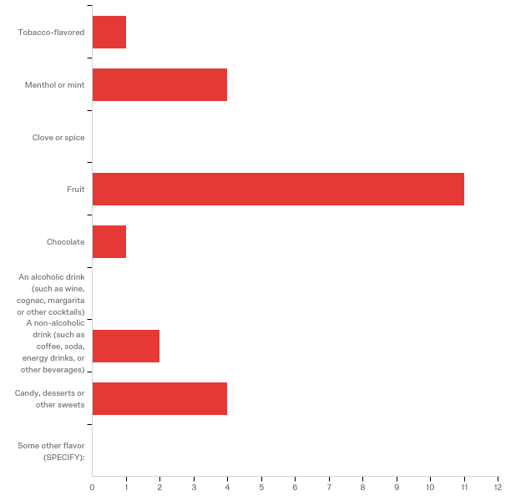

|  |  |  |  |
| --- | --- | --- | --- |
| # | Answer | % | Count |
| 1 | Tobacco-flavored | 4.35% | 1 |
| 2 | Menthol or mint | 17.39% | 4 |
| 3 | Clove or spice | 0.00% | 0 |
| 4 | Fruit | 47.83% | 11 |
| 5 | Chocolate | 4.35% | 1 |
| 6 | An alcoholic drink (such as wine, cognac, margarita or other cocktails) | 0.00% | 0 |
| 7 | A non-alcoholic drink (such as coffee, soda, energy drinks, or other beverages) | 8.70% | 2 |
| 8 | Candy, desserts or other sweets | 17.39% | 4 |
| 9 | Some other flavor (SPECIFY): | 0.00% | 0 |
|  | Total | 100% | 23 |

Q27_9_TEXT - Some other flavor (SPECIFY):  
Some other flavor (SPECIFY): - Text

**Q28 - How many cigarettes have you smoked in your entire life? A pack usually
has 20 cigarettes in it. (Choose one)**

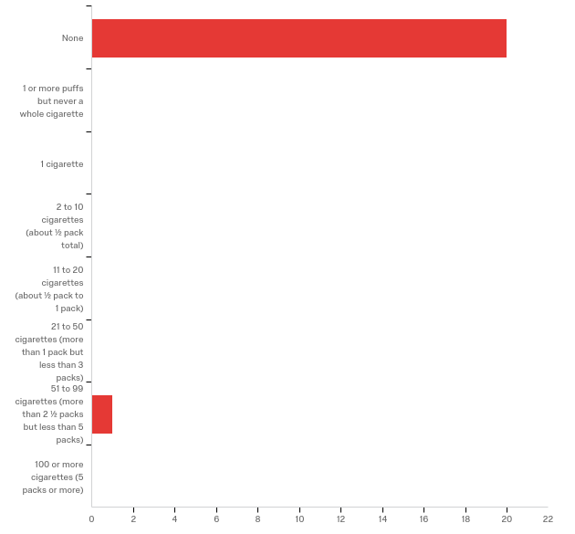

|  |  |  |  |  |  |  |  |
| --- | --- | --- | --- | --- | --- | --- | --- |
| # | Field | Minimum | Maximum | Mean | Std Deviation | Variance | Count |
| 1 | How many cigarettes have you smoked in your entire life? A pack usually has 20 cigarettes in it. (Choose one) | 1.00 | 8.00 | 1.33 | 1.49 | 2.22 | 21 |

|  |  |  |  |
| --- | --- | --- | --- |
| # | Answer | % | Count |
| 1 | None | 95.24% | 20 |
| 2 | 1 or more puffs but never a whole cigarette | 0.00% | 0 |
| 3 | 1 cigarette | 0.00% | 0 |
| 4 | 2 to 10 cigarettes (about ½ pack total) | 0.00% | 0 |
| 5 | 11 to 20 cigarettes (about ½ pack to 1 pack) | 0.00% | 0 |
| 6 | 21 to 50 cigarettes (more than 1 pack but less than 3 packs) | 0.00% | 0 |
| 8 | 51 to 99 cigarettes (more than 2 ½ packs but less than 5 packs) | 4.76% | 1 |
| 9 | 100 or more cigarettes (5 packs or more) | 0.00% | 0 |
|  | Total | 100% | 21 |

**Q29 - Do you consider yourself a
smoker?**

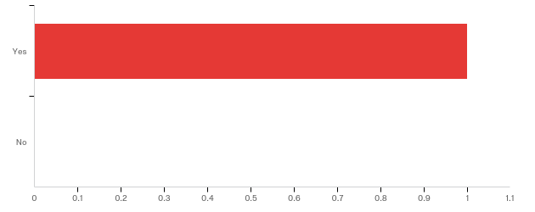

|  |  |  |  |  |  |  |  |
| --- | --- | --- | --- | --- | --- | --- | --- |
| # | Field | Minimum | Maximum | Mean | Std Deviation | Variance | Count |
| 1 | Do you consider yourself a smoker? | 1.00 | 1.00 | 1.00 | 0.00 | 0.00 | 1 |

|  |  |  |  |
| --- | --- | --- | --- |
| # | Answer | % | Count |
| 1 | Yes | 100.00% | 1 |
| 2 | No | 0.00% | 0 |
|  | Total | 100% | 1 |

**Q30 - In the past 30 days, on the days you smoked, how many cigarettes did you
smoke per day? A
pack usually has 20 cigarettes in it. (Choose one)**

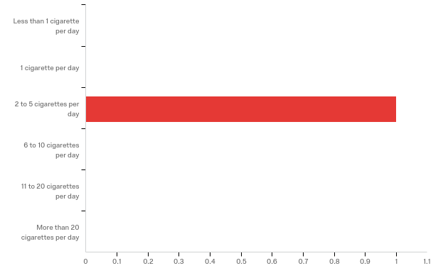

|  |  |  |  |  |  |  |  |
| --- | --- | --- | --- | --- | --- | --- | --- |
| # | Field | Minimum | Maximum | Mean | Std Deviation | Variance | Count |
| 1 | In the past 30 days, on the days you smoked, how many cigarettes did you smoke per day? A pack usually has 20 cigarettes in it. (Choose one) | 3.00 | 3.00 | 3.00 | 0.00 | 0.00 | 1 |

|  |  |  |  |
| --- | --- | --- | --- |
| # | Answer | % | Count |
| 1 | Less than 1 cigarette per day | 0.00% | 0 |
| 2 | 1 cigarette per day | 0.00% | 0 |
| 3 | 2 to 5 cigarettes per day | 100.00% | 1 |
| 4 | 6 to 10 cigarettes per day | 0.00% | 0 |
| 5 | 11 to 20 cigarettes per day | 0.00% | 0 |
| 6 | More than 20 cigarettes per day | 0.00% | 0 |
|  | Total | 100% | 1 |

**Q31 - During
the past 30 days, how many times did you use marijuana?**

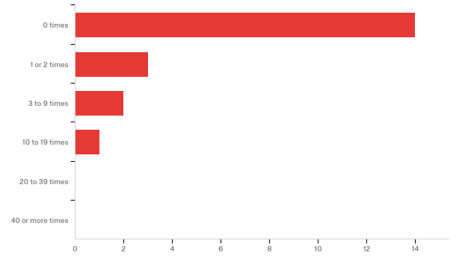

|  |  |  |  |  |  |  |  |
| --- | --- | --- | --- | --- | --- | --- | --- |
| # | Field | Minimum | Maximum | Mean | Std Deviation | Variance | Count |
| 1 | During the past 30 days, how many times did you use marijuana? | 2.00 | 5.00 | 2.50 | 0.87 | 0.75 | 20 |

|  |  |  |  |
| --- | --- | --- | --- |
| # | Answer | % | Count |
| 2 | 0 times | 70.00% | 14 |
| 3 | 1 or 2 times | 15.00% | 3 |
| 4 | 3 to 9 times | 10.00% | 2 |
| 5 | 10 to 19 times | 5.00% | 1 |
| 6 | 20 to 39 times | 0.00% | 0 |
| 7 | 40 or more times | 0.00% | 0 |
|  | Total | 100% | 20 |

**Q77 - Have you ever used marijuana edibles? (choose one)**

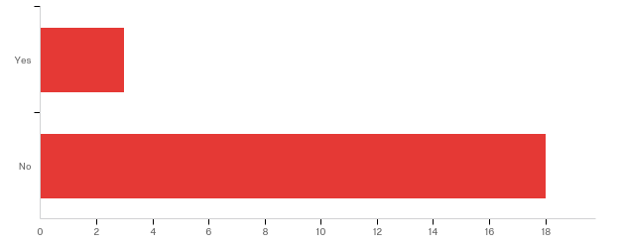

|  |  |  |  |  |  |  |  |
| --- | --- | --- | --- | --- | --- | --- | --- |
| # | Field | Minimum | Maximum | Mean | Std Deviation | Variance | Count |
| 1 | Have you ever used marijuana edibles? (choose one) | 1.00 | 2.00 | 1.86 | 0.35 | 0.12 | 21 |

|  |  |  |  |
| --- | --- | --- | --- |
| # | Answer | % | Count |
| 1 | Yes | 14.29% | 3 |
| 2 | No | 85.71% | 18 |
|  | Total | 100% | 21 |

**Q78 - Do you currently use marijuana edibles?**

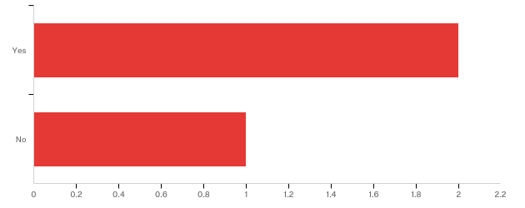

|  |  |  |  |  |  |  |  |
| --- | --- | --- | --- | --- | --- | --- | --- |
| # | Field | Minimum | Maximum | Mean | Std Deviation | Variance | Count |
| 1 | Do you currently use marijuana edibles? | 1.00 | 2.00 | 1.33 | 0.47 | 0.22 | 3 |

|  |  |  |  |
| --- | --- | --- | --- |
| # | Answer | % | Count |
| 1 | Yes | 66.67% | 2 |
| 2 | No | 33.33% | 1 |
|  | Total | 100% | 3 |

**Q119 - During the past 30 days, on how many days did you have at least one drink of alcohol? (Choose one)**

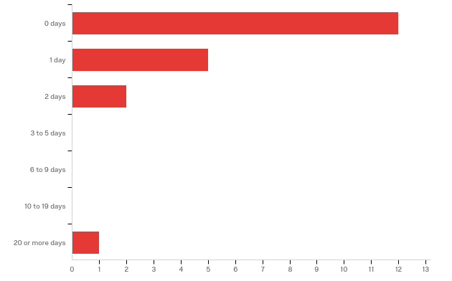

|  |  |  |  |  |  |  |  |
| --- | --- | --- | --- | --- | --- | --- | --- |
| # | Field | Minimum | Maximum | Mean | Std Deviation | Variance | Count |
| 1 | During the past 30 days, on how many days did you have at least one drink of alcohol? (Choose one) | 1.00 | 7.00 | 1.75 | 1.37 | 1.89 | 20 |

|  |  |  |  |
| --- | --- | --- | --- |
| # | Answer | % | Count |
| 1 | 0 days | 60.00% | 12 |
| 2 | 1 day | 25.00% | 5 |
| 3 | 2 days | 10.00% | 2 |
| 4 | 3 to 5 days | 0.00% | 0 |
| 5 | 6 to 9 days | 0.00% | 0 |
| 6 | 10 to 19 days | 0.00% | 0 |
| 7 | 20 or more days | 5.00% | 1 |
|  | Total | 100% | 20 |

**Q33 - Does anyone who
lives in your home use any of the following products regularly? (Do not count
yourself) Mark the products that are used by someone in your home.**

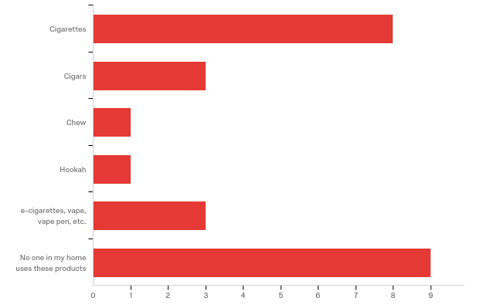

|  |  |  |  |
| --- | --- | --- | --- |
| # | Answer | % | Count |
| 1 | Cigarettes | 32.00% | 8 |
| 2 | Cigars | 12.00% | 3 |
| 3 | Chew | 4.00% | 1 |
| 4 | Hookah | 4.00% | 1 |
| 5 | e-cigarettes, vape, vape pen, etc. | 12.00% | 3 |
| 6 | No one in my home uses these products | 36.00% | 9 |
|  | Total | 100% | 25 |

**Q34 - Have
you had any cough in the previous 2 weeks?**

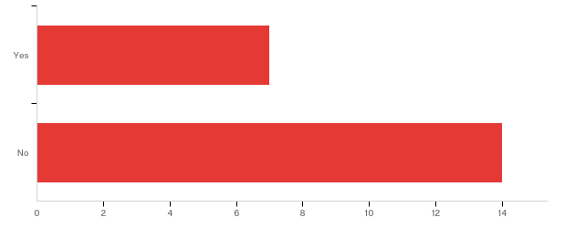

|  |  |  |  |  |  |  |  |
| --- | --- | --- | --- | --- | --- | --- | --- |
| # | Field | Minimum | Maximum | Mean | Std Deviation | Variance | Count |
| 1 | Have you had any cough in the previous 2 weeks? | 1.00 | 2.00 | 1.67 | 0.47 | 0.22 | 21 |

|  |  |  |  |
| --- | --- | --- | --- |
| # | Answer | % | Count |
| 1 | Yes | 33.33% | 7 |
| 2 | No | 66.67% | 14 |
|  | Total | 100% | 21 |

**Q35 - Have
you heard any wheezing when breathing?**

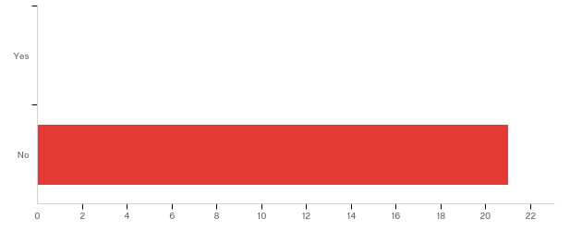

|  |  |  |  |  |  |  |  |
| --- | --- | --- | --- | --- | --- | --- | --- |
| # | Field | Minimum | Maximum | Mean | Std Deviation | Variance | Count |
| 1 | Have you heard any wheezing when breathing? | 2.00 | 2.00 | 2.00 | 0.00 | 0.00 | 21 |

|  |  |  |  |
| --- | --- | --- | --- |
| # | Answer | % | Count |
| 1 | Yes | 0.00% | 0 |
| 2 | No | 100.00% | 21 |
|  | Total | 100% | 21 |

**Q36 - Have
you been short of breath in the previous 2 weeks?**

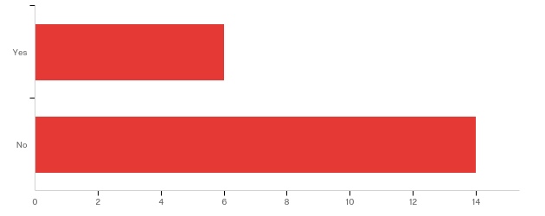

|  |  |  |  |  |  |  |  |
| --- | --- | --- | --- | --- | --- | --- | --- |
| # | Field | Minimum | Maximum | Mean | Std Deviation | Variance | Count |
| 1 | Have you been short of breath in the previous 2 weeks? | 1.00 | 2.00 | 1.70 | 0.46 | 0.21 | 20 |

|  |  |  |  |
| --- | --- | --- | --- |
| # | Answer | % | Count |
| 1 | Yes | 30.00% | 6 |
| 2 | No | 70.00% | 14 |
|  | Total | 100% | 20 |

**Q37 - Have
you had difficulty in breathing like a sensation of pressure on your chest?**

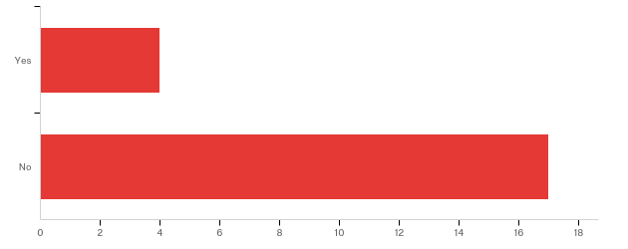

|  |  |  |  |  |  |  |  |
| --- | --- | --- | --- | --- | --- | --- | --- |
| # | Field | Minimum | Maximum | Mean | Std Deviation | Variance | Count |
| 1 | Have you had difficulty in breathing like a sensation of pressure on your chest? | 1.00 | 2.00 | 1.81 | 0.39 | 0.15 | 21 |

|  |  |  |  |
| --- | --- | --- | --- |
| # | Answer | % | Count |
| 1 | Yes | 19.05% | 4 |
| 2 | No | 80.95% | 17 |
|  | Total | 100% | 21 |

**Q38 - Has
a doctor or nurse ever told you that you have asthma?**

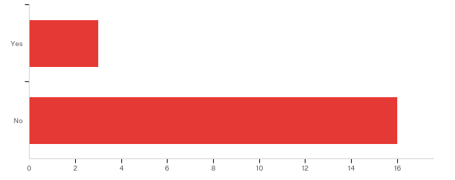

|  |  |  |  |  |  |  |  |
| --- | --- | --- | --- | --- | --- | --- | --- |
| # | Field | Minimum | Maximum | Mean | Std Deviation | Variance | Count |
| 1 | Has a doctor or nurse ever told you that you have asthma? | 1.00 | 2.00 | 1.84 | 0.36 | 0.13 | 19 |

|  |  |  |  |
| --- | --- | --- | --- |
| # | Answer | % | Count |
| 1 | Yes | 15.79% | 3 |
| 2 | No | 84.21% | 16 |
|  | Total | 100% | 19 |

**Q118 - Do you have any history of lung diseases (asthma, COPD, etc)?**

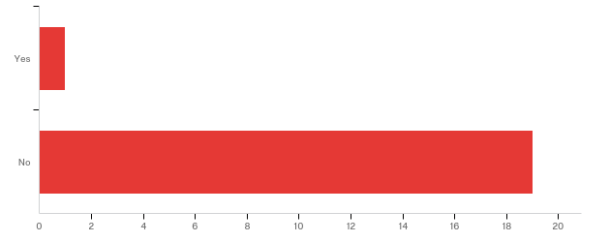

|  |  |  |  |  |  |  |  |
| --- | --- | --- | --- | --- | --- | --- | --- |
| # | Field | Minimum | Maximum | Mean | Std Deviation | Variance | Count |
| 1 | Do you have any history of lung diseases (asthma, COPD, etc)? | 1.00 | 2.00 | 1.95 | 0.22 | 0.05 | 20 |

|  |  |  |  |
| --- | --- | --- | --- |
| # | Answer | % | Count |
| 1 | Yes | 5.00% | 1 |
| 2 | No | 95.00% | 19 |
|  | Total | 100% | 20 |

**Q120 - What lung disease do you have?**

What lung disease do you have?

**Q86 - Please describe who is friends with whom. For example, friend 1, 2 and 3 are all friends. Friends 4 and 5 are friends.**

|  |
| --- |
| Please describe who is friends with whom. For example, friend 1, 2 and 3 are all friends. Friends 4 and 5 are friends. |
| Friends 1 and 2 are family members that come around twice a year |
| All are classmates and friends with each other |
| All friends |
| friend 1 to 2, 2 to 3m 3 to 4, 4 to 5, 5 to 6 |
| Friend 1,2,3 and 4; Friends 1, 6 and 5 |
| Friends- 1, 2, 3, 4 together. friends 5 and 6 are friends |
| Friends- 1,2,3 and 6 |

**Q84 - Which best describes your level of friendship with friend #1? (choose one)**

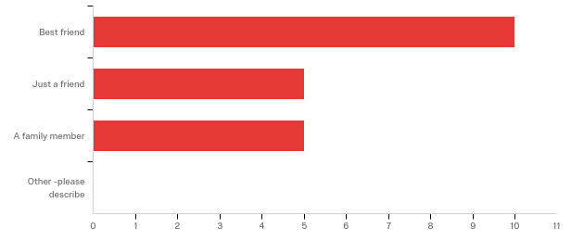

|  |  |  |  |  |  |  |  |
| --- | --- | --- | --- | --- | --- | --- | --- |
| # | Field | Minimum | Maximum | Mean | Std Deviation | Variance | Count |
| 1 | Which best describes your level of friendship with friend #1? (choose one) - Selected Choice | 1.00 | 3.00 | 1.75 | 0.83 | 0.69 | 20 |

|  |  |  |  |
| --- | --- | --- | --- |
| # | Answer | % | Count |
| 1 | Best friend | 50.00% | 10 |
| 2 | Just a friend | 25.00% | 5 |
| 3 | A family member | 25.00% | 5 |
| 4 | Other -please describe | 0.00% | 0 |
|  | Total | 100% | 20 |

Q84_4_TEXT - Other -please describe  
Other -please describe - Text

**Q85 - Is this friend.....(choose one)**

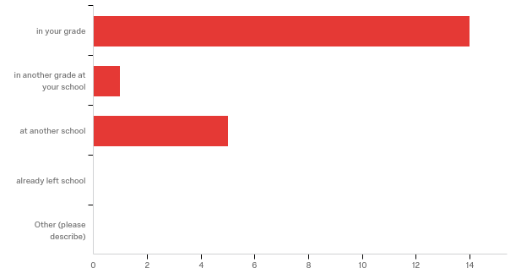

|  |  |  |  |  |  |  |  |
| --- | --- | --- | --- | --- | --- | --- | --- |
| # | Field | Minimum | Maximum | Mean | Std Deviation | Variance | Count |
| 1 | Is this friend.....(choose one) - Selected Choice | 1.00 | 4.00 | 1.80 | 1.29 | 1.66 | 20 |

|  |  |  |  |
| --- | --- | --- | --- |
| # | Answer | % | Count |
| 1 | in your grade | 70.00% | 14 |
| 2 | in another grade at your school | 5.00% | 1 |
| 4 | at another school | 25.00% | 5 |
| 5 | already left school | 0.00% | 0 |
| 6 | Other (please describe) | 0.00% | 0 |
|  | Total | 100% | 20 |

Q85_6_TEXT - Other (please describe)  
Other (please describe) - Text

**Q87 - When do you hang out with this friend? (choose one)**

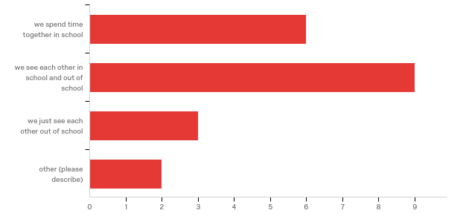

|  |  |  |  |  |  |  |  |
| --- | --- | --- | --- | --- | --- | --- | --- |
| # | Field | Minimum | Maximum | Mean | Std Deviation | Variance | Count |
| 1 | When do you hang out with this friend? (choose one) - Selected Choice | 1.00 | 4.00 | 2.05 | 0.92 | 0.85 | 20 |

|  |  |  |  |
| --- | --- | --- | --- |
| # | Answer | % | Count |
| 1 | we spend time together in school | 30.00% | 6 |
| 2 | we see each other in school and out of school | 45.00% | 9 |
| 3 | we just see each other out of school | 15.00% | 3 |
| 4 | other (please describe) | 10.00% | 2 |
|  | Total | 100% | 20 |

Q87_4_TEXT - other (please describe)

|  |
| --- |
| other (please describe) - Text |
| only when they come around |
| family events |

**Q88 - What do you as friends together? (choose all that apply)**

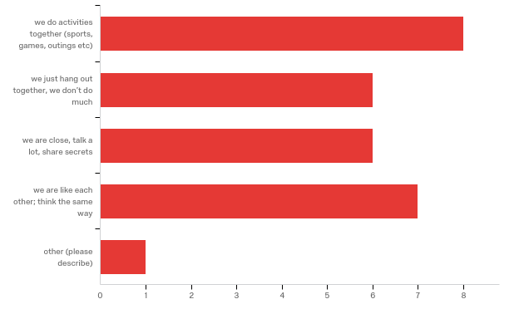

|  |  |  |  |
| --- | --- | --- | --- |
| # | Answer | % | Count |
| 1 | we do activities together (sports, games, outings etc) | 28.57% | 8 |
| 2 | we just hang out together, we don’t do much | 21.43% | 6 |
| 3 | we are close, talk a lot, share secrets | 21.43% | 6 |
| 4 | we are like each other; think the same way | 25.00% | 7 |
| 5 | other (please describe) | 3.57% | 1 |
|  | Total | 100% | 28 |

Q88_5_TEXT - other (please describe)

|  |
| --- |
| other (please describe) - Text |
| In a band |

**Q89 - Does friend #1 vape regularly?**

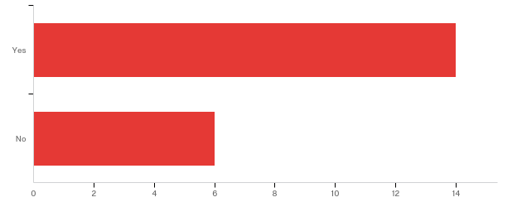

|  |  |  |  |  |  |  |  |
| --- | --- | --- | --- | --- | --- | --- | --- |
| # | Field | Minimum | Maximum | Mean | Std Deviation | Variance | Count |
| 1 | Does friend #1 vape regularly? | 1.00 | 2.00 | 1.30 | 0.46 | 0.21 | 20 |

|  |  |  |  |
| --- | --- | --- | --- |
| # | Answer | % | Count |
| 1 | Yes | 70.00% | 14 |
| 2 | No | 30.00% | 6 |
|  | Total | 100% | 20 |

**Q90 - How does friend #1 get their vape/Juul/e-cigarettes products (oils, device,
etc)? (check one)**

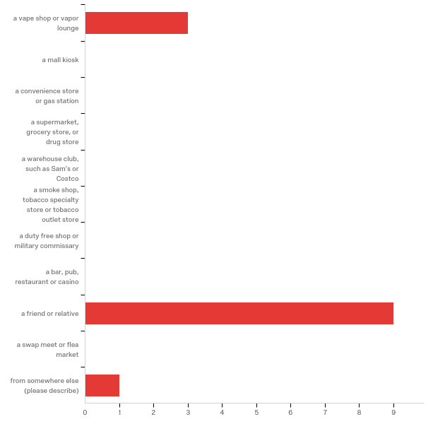

|  |  |  |  |  |  |  |  |
| --- | --- | --- | --- | --- | --- | --- | --- |
| # | Field | Minimum | Maximum | Mean | Std Deviation | Variance | Count |
| 1 | How does friend #1 get their vape/Juul/e-cigarettes products (oils, device, etc)? (check one) - Selected Choice | 1.00 | 11.00 | 7.31 | 3.49 | 12.21 | 13 |

|  |  |  |  |
| --- | --- | --- | --- |
| # | Answer | % | Count |
| 1 | a vape shop or vapor lounge | 23.08% | 3 |
| 2 | a mall kiosk | 0.00% | 0 |
| 3 | a convenience store or gas station | 0.00% | 0 |
| 4 | a supermarket, grocery store, or drug store | 0.00% | 0 |
| 5 | a warehouse club, such as Sam’s or Costco | 0.00% | 0 |
| 6 | a smoke shop, tobacco specialty store or tobacco outlet store | 0.00% | 0 |
| 7 | a duty free shop or military commissary | 0.00% | 0 |
| 8 | a bar, pub, restaurant or casino | 0.00% | 0 |
| 9 | a friend or relative | 69.23% | 9 |
| 10 | a swap meet or flea market | 0.00% | 0 |
| 11 | from somewhere else (please describe) | 7.69% | 1 |
|  | Total | 100% | 13 |

Q90_11_TEXT - from somewhere else (please describe)  
from somewhere else (please describe) - Text

**Q91 - How often does friend #1 give you either the device or supplies,
including oils for you to be able to vape? (choose one)**

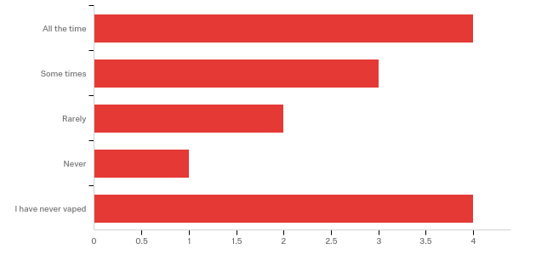

|  |  |  |  |  |  |  |  |
| --- | --- | --- | --- | --- | --- | --- | --- |
| # | Field | Minimum | Maximum | Mean | Std Deviation | Variance | Count |
| 1 | How often does friend #1 give you either the device or supplies, including oils for you to be able to vape? (choose one) | 1.00 | 5.00 | 2.86 | 1.60 | 2.55 | 14 |

|  |  |  |  |
| --- | --- | --- | --- |
| # | Answer | % | Count |
| 1 | All the time | 28.57% | 4 |
| 2 | Some times | 21.43% | 3 |
| 3 | Rarely | 14.29% | 2 |
| 4 | Never | 7.14% | 1 |
| 5 | I have never vaped | 28.57% | 4 |
|  | Total | 100% | 14 |

**Q73 - Which best describes your level of friendship with friend #2? (choose one)**

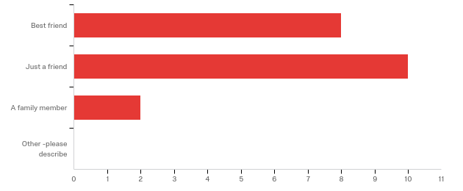

|  |  |  |  |  |  |  |  |
| --- | --- | --- | --- | --- | --- | --- | --- |
| # | Field | Minimum | Maximum | Mean | Std Deviation | Variance | Count |
| 1 | Which best describes your level of friendship with friend #2? (choose one) - Selected Choice | 1.00 | 3.00 | 1.70 | 0.64 | 0.41 | 20 |

|  |  |  |  |
| --- | --- | --- | --- |
| # | Answer | % | Count |
| 1 | Best friend | 40.00% | 8 |
| 2 | Just a friend | 50.00% | 10 |
| 3 | A family member | 10.00% | 2 |
| 4 | Other -please describe | 0.00% | 0 |
|  | Total | 100% | 20 |

Q73_4_TEXT - Other -please describe  
Other -please describe - Text

**Q81 - Is this friend.....(choose one)**



|  |  |  |  |  |  |  |  |
| --- | --- | --- | --- | --- | --- | --- | --- |
| # | Field | Minimum | Maximum | Mean | Std Deviation | Variance | Count |
| 1 | Is this friend.....(choose one) - Selected Choice | 1.00 | 4.00 | 1.80 | 1.29 | 1.66 | 20 |

|  |  |  |  |
| --- | --- | --- | --- |
| # | Answer | % | Count |
| 1 | in your grade | 70.00% | 14 |
| 2 | in another grade at your school | 5.00% | 1 |
| 4 | at another school | 25.00% | 5 |
| 5 | already left school | 0.00% | 0 |
| 6 | Other (please describe) | 0.00% | 0 |
|  | Total | 100% | 20 |

Q81_6_TEXT - Other (please describe)  
Other (please describe) - Text

**Q90 - When do you hang out with this friend? (choose one)**

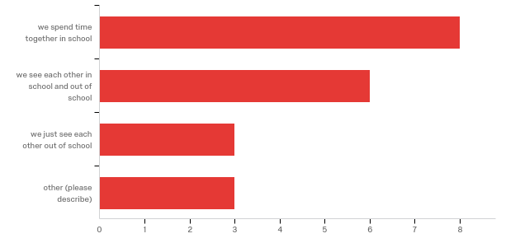

|  |  |  |  |  |  |  |  |
| --- | --- | --- | --- | --- | --- | --- | --- |
| # | Field | Minimum | Maximum | Mean | Std Deviation | Variance | Count |
| 1 | When do you hang out with this friend? (choose one) - Selected Choice | 1.00 | 4.00 | 2.05 | 1.07 | 1.15 | 20 |

|  |  |  |  |
| --- | --- | --- | --- |
| # | Answer | % | Count |
| 1 | we spend time together in school | 40.00% | 8 |
| 2 | we see each other in school and out of school | 30.00% | 6 |
| 3 | we just see each other out of school | 15.00% | 3 |
| 4 | other (please describe) | 15.00% | 3 |
|  | Total | 100% | 20 |

Q90_4_TEXT - other (please describe)

|  |
| --- |
| other (please describe) - Text |
| spend time at the club |
| unk |
| text each other |

**Q95 - What do you as friends together? (choose all that apply)**

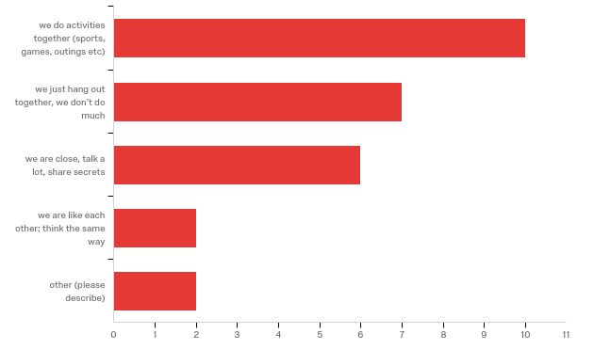

|  |  |  |  |
| --- | --- | --- | --- |
| # | Answer | % | Count |
| 1 | we do activities together (sports, games, outings etc) | 37.04% | 10 |
| 2 | we just hang out together, we don’t do much | 25.93% | 7 |
| 3 | we are close, talk a lot, share secrets | 22.22% | 6 |
| 4 | we are like each other; think the same way | 7.41% | 2 |
| 5 | other (please describe) | 7.41% | 2 |
|  | Total | 100% | 27 |

Q95_5_TEXT - other (please describe)

|  |
| --- |
| other (please describe) - Text |
| smoke marijuana |
| see each other often |

**Q97 - Does friend #2 vape regularly?**

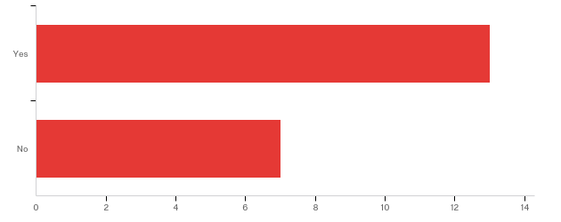

|  |  |  |  |  |  |  |  |
| --- | --- | --- | --- | --- | --- | --- | --- |
| # | Field | Minimum | Maximum | Mean | Std Deviation | Variance | Count |
| 1 | Does friend #2 vape regularly? | 1.00 | 2.00 | 1.35 | 0.48 | 0.23 | 20 |

|  |  |  |  |
| --- | --- | --- | --- |
| # | Answer | % | Count |
| 1 | Yes | 65.00% | 13 |
| 2 | No | 35.00% | 7 |
|  | Total | 100% | 20 |

**Q102 - How does friend #2 get their vape/Juul/e-cigarettes products (oils, device,
etc)? (check one)**

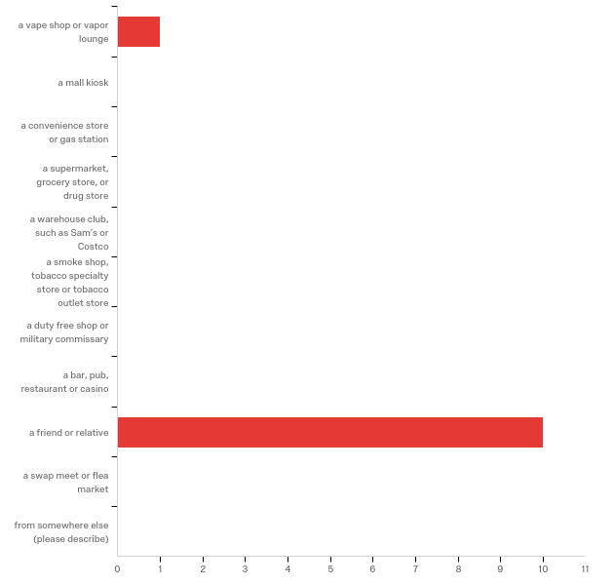

|  |  |  |  |  |  |  |  |
| --- | --- | --- | --- | --- | --- | --- | --- |
| # | Field | Minimum | Maximum | Mean | Std Deviation | Variance | Count |
| 1 | How does friend #2 get their vape/Juul/e-cigarettes products (oils, device, etc)? (check one) - Selected Choice | 1.00 | 9.00 | 8.27 | 2.30 | 5.29 | 11 |

|  |  |  |  |
| --- | --- | --- | --- |
| # | Answer | % | Count |
| 1 | a vape shop or vapor lounge | 9.09% | 1 |
| 2 | a mall kiosk | 0.00% | 0 |
| 3 | a convenience store or gas station | 0.00% | 0 |
| 4 | a supermarket, grocery store, or drug store | 0.00% | 0 |
| 5 | a warehouse club, such as Sam’s or Costco | 0.00% | 0 |
| 6 | a smoke shop, tobacco specialty store or tobacco outlet store | 0.00% | 0 |
| 7 | a duty free shop or military commissary | 0.00% | 0 |
| 8 | a bar, pub, restaurant or casino | 0.00% | 0 |
| 9 | a friend or relative | 90.91% | 10 |
| 10 | a swap meet or flea market | 0.00% | 0 |
| 11 | from somewhere else (please describe) | 0.00% | 0 |
|  | Total | 100% | 11 |

Q102_11_TEXT - from somewhere else (please describe)  
from somewhere else (please describe) - Text

**Q107 - How often does friend #2 give you either the device or supplies,
including oils for you to be able to vape? (choose one)**

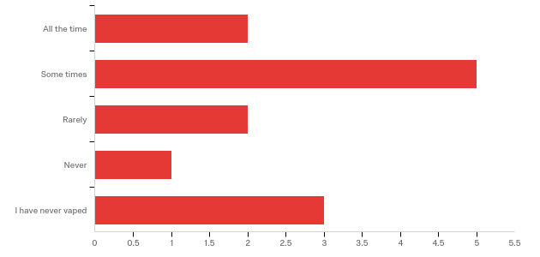

|  |  |  |  |  |  |  |  |
| --- | --- | --- | --- | --- | --- | --- | --- |
| # | Field | Minimum | Maximum | Mean | Std Deviation | Variance | Count |
| 1 | How often does friend #2 give you either the device or supplies, including oils for you to be able to vape? (choose one) | 1.00 | 5.00 | 2.85 | 1.41 | 1.98 | 13 |

|  |  |  |  |
| --- | --- | --- | --- |
| # | Answer | % | Count |
| 1 | All the time | 15.38% | 2 |
| 2 | Some times | 38.46% | 5 |
| 3 | Rarely | 15.38% | 2 |
| 4 | Never | 7.69% | 1 |
| 5 | I have never vaped | 23.08% | 3 |
|  | Total | 100% | 13 |

**Q76 - Which best describes your level of friendship with friend #3? (choose one)**

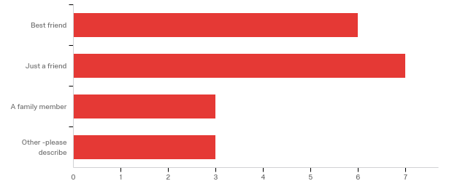

|  |  |  |  |  |  |  |  |
| --- | --- | --- | --- | --- | --- | --- | --- |
| # | Field | Minimum | Maximum | Mean | Std Deviation | Variance | Count |
| 1 | Which best describes your level of friendship with friend #3? (choose one) - Selected Choice | 1.00 | 4.00 | 2.16 | 1.04 | 1.08 | 19 |

|  |  |  |  |
| --- | --- | --- | --- |
| # | Answer | % | Count |
| 1 | Best friend | 31.58% | 6 |
| 2 | Just a friend | 36.84% | 7 |
| 3 | A family member | 15.79% | 3 |
| 4 | Other -please describe | 15.79% | 3 |
|  | Total | 100% | 19 |

Q76_4_TEXT - Other -please describe

|  |
| --- |
| Other -please describe - Text |
| classmate |
| girlfriend |
| boyfriend and best friend |

**Q82 - Is this friend.....(choose one)**

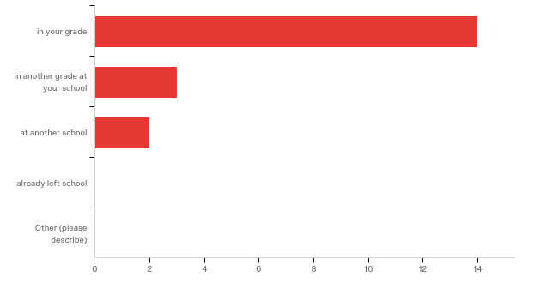

|  |  |  |  |  |  |  |  |
| --- | --- | --- | --- | --- | --- | --- | --- |
| # | Field | Minimum | Maximum | Mean | Std Deviation | Variance | Count |
| 1 | Is this friend.....(choose one) - Selected Choice | 1.00 | 4.00 | 1.47 | 0.94 | 0.88 | 19 |

|  |  |  |  |
| --- | --- | --- | --- |
| # | Answer | % | Count |
| 1 | in your grade | 73.68% | 14 |
| 2 | in another grade at your school | 15.79% | 3 |
| 4 | at another school | 10.53% | 2 |
| 5 | already left school | 0.00% | 0 |
| 6 | Other (please describe) | 0.00% | 0 |
|  | Total | 100% | 19 |

Q82_6_TEXT - Other (please describe)  
Other (please describe) - Text

**Q113 - When do you hang out with this friend? (choose one)**

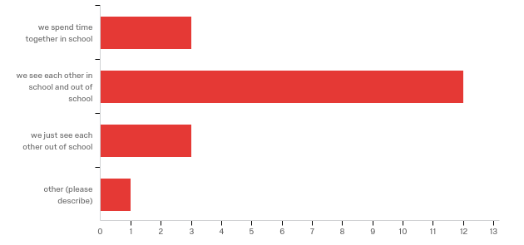

|  |  |  |  |  |  |  |  |
| --- | --- | --- | --- | --- | --- | --- | --- |
| # | Field | Minimum | Maximum | Mean | Std Deviation | Variance | Count |
| 1 | When do you hang out with this friend? (choose one) - Selected Choice | 1.00 | 4.00 | 2.11 | 0.72 | 0.52 | 19 |

|  |  |  |  |
| --- | --- | --- | --- |
| # | Answer | % | Count |
| 1 | we spend time together in school | 15.79% | 3 |
| 2 | we see each other in school and out of school | 63.16% | 12 |
| 3 | we just see each other out of school | 15.79% | 3 |
| 4 | other (please describe) | 5.26% | 1 |
|  | Total | 100% | 19 |

Q113_4_TEXT - other (please describe)

|  |
| --- |
| other (please describe) - Text |
| we see in school |

**Q94 - What do you as friends together? (choose all that apply)**

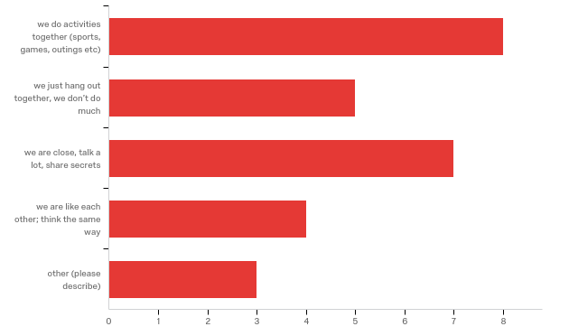

|  |  |  |  |
| --- | --- | --- | --- |
| # | Answer | % | Count |
| 1 | we do activities together (sports, games, outings etc) | 29.63% | 8 |
| 2 | we just hang out together, we don’t do much | 18.52% | 5 |
| 3 | we are close, talk a lot, share secrets | 25.93% | 7 |
| 4 | we are like each other; think the same way | 14.81% | 4 |
| 5 | other (please describe) | 11.11% | 3 |
|  | Total | 100% | 27 |

Q94_5_TEXT - other (please describe)

|  |
| --- |
| other (please describe) - Text |
| smoke marijuana |
| classwork |
| In a band |

**Q98 - Does friend #3 vape regularly?**

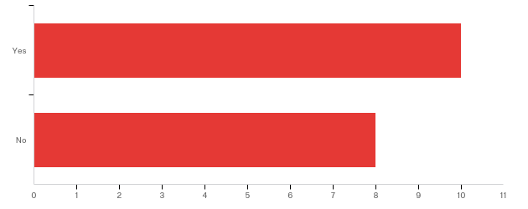

|  |  |  |  |  |  |  |  |
| --- | --- | --- | --- | --- | --- | --- | --- |
| # | Field | Minimum | Maximum | Mean | Std Deviation | Variance | Count |
| 1 | Does friend #3 vape regularly? | 1.00 | 2.00 | 1.44 | 0.50 | 0.25 | 18 |

|  |  |  |  |
| --- | --- | --- | --- |
| # | Answer | % | Count |
| 1 | Yes | 55.56% | 10 |
| 2 | No | 44.44% | 8 |
|  | Total | 100% | 18 |

**Q103 - How does friend #3 get their vape/Juul/e-cigarettes products (oils, device,
etc)? (check one)**

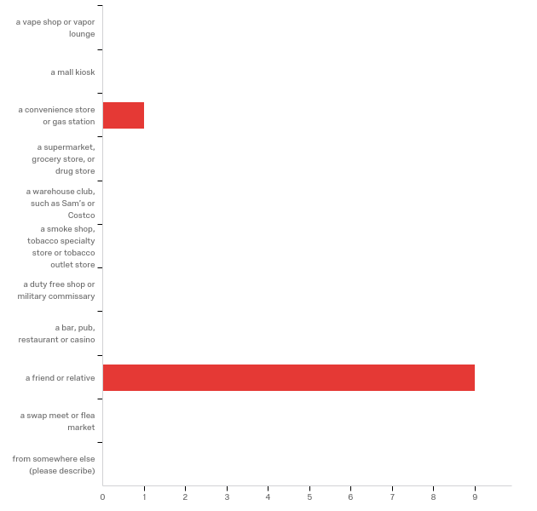

|  |  |  |  |  |  |  |  |
| --- | --- | --- | --- | --- | --- | --- | --- |
| # | Field | Minimum | Maximum | Mean | Std Deviation | Variance | Count |
| 1 | How does friend #3 get their vape/Juul/e-cigarettes products (oils, device, etc)? (check one) - Selected Choice | 3.00 | 9.00 | 8.40 | 1.80 | 3.24 | 10 |

|  |  |  |  |
| --- | --- | --- | --- |
| # | Answer | % | Count |
| 1 | a vape shop or vapor lounge | 0.00% | 0 |
| 2 | a mall kiosk | 0.00% | 0 |
| 3 | a convenience store or gas station | 10.00% | 1 |
| 4 | a supermarket, grocery store, or drug store | 0.00% | 0 |
| 5 | a warehouse club, such as Sam’s or Costco | 0.00% | 0 |
| 6 | a smoke shop, tobacco specialty store or tobacco outlet store | 0.00% | 0 |
| 7 | a duty free shop or military commissary | 0.00% | 0 |
| 8 | a bar, pub, restaurant or casino | 0.00% | 0 |
| 9 | a friend or relative | 90.00% | 9 |
| 10 | a swap meet or flea market | 0.00% | 0 |
| 11 | from somewhere else (please describe) | 0.00% | 0 |
|  | Total | 100% | 10 |

Q103_11_TEXT - from somewhere else (please describe)  
from somewhere else (please describe) - Text

**Q108 - How often does friend #3 give you either the device or supplies,
including oils for you to be able to vape? (choose one)**

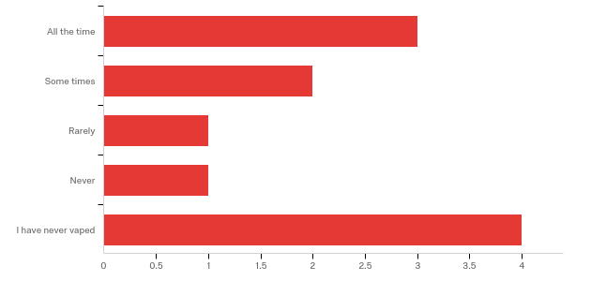

|  |  |  |  |  |  |  |  |
| --- | --- | --- | --- | --- | --- | --- | --- |
| # | Field | Minimum | Maximum | Mean | Std Deviation | Variance | Count |
| 1 | How often does friend #3 give you either the device or supplies, including oils for you to be able to vape? (choose one) | 1.00 | 5.00 | 3.09 | 1.68 | 2.81 | 11 |

|  |  |  |  |
| --- | --- | --- | --- |
| # | Answer | % | Count |
| 1 | All the time | 27.27% | 3 |
| 2 | Some times | 18.18% | 2 |
| 3 | Rarely | 9.09% | 1 |
| 4 | Never | 9.09% | 1 |
| 5 | I have never vaped | 36.36% | 4 |
|  | Total | 100% | 11 |

**Q78 - Which best describes your level of friendship with friend #4? (choose one)**

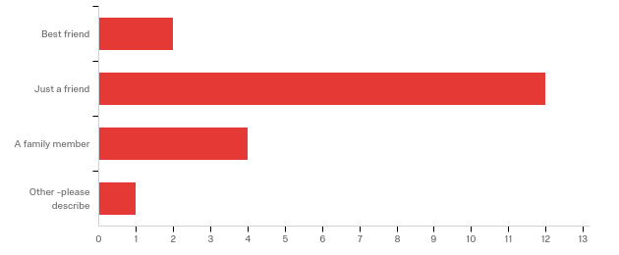

|  |  |  |  |  |  |  |  |
| --- | --- | --- | --- | --- | --- | --- | --- |
| # | Field | Minimum | Maximum | Mean | Std Deviation | Variance | Count |
| 1 | Which best describes your level of friendship with friend #4? (choose one) - Selected Choice | 1.00 | 4.00 | 2.21 | 0.69 | 0.48 | 19 |

|  |  |  |  |
| --- | --- | --- | --- |
| # | Answer | % | Count |
| 1 | Best friend | 10.53% | 2 |
| 2 | Just a friend | 63.16% | 12 |
| 3 | A family member | 21.05% | 4 |
| 4 | Other -please describe | 5.26% | 1 |
|  | Total | 100% | 19 |

Q78_4_TEXT - Other -please describe

|  |
| --- |
| Other -please describe - Text |
| one of my friend's friend |

**Q84 - Is this friend.....(choose one)**

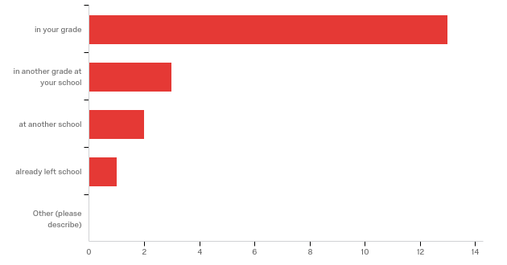

|  |  |  |  |  |  |  |  |
| --- | --- | --- | --- | --- | --- | --- | --- |
| # | Field | Minimum | Maximum | Mean | Std Deviation | Variance | Count |
| 1 | Is this friend.....(choose one) - Selected Choice | 1.00 | 5.00 | 1.68 | 1.22 | 1.48 | 19 |

|  |  |  |  |
| --- | --- | --- | --- |
| # | Answer | % | Count |
| 1 | in your grade | 68.42% | 13 |
| 2 | in another grade at your school | 15.79% | 3 |
| 4 | at another school | 10.53% | 2 |
| 5 | already left school | 5.26% | 1 |
| 6 | Other (please describe) | 0.00% | 0 |
|  | Total | 100% | 19 |

Q84_6_TEXT - Other (please describe)  
Other (please describe) - Text

**Q88 - When do you hang out with this friend? (choose one)**

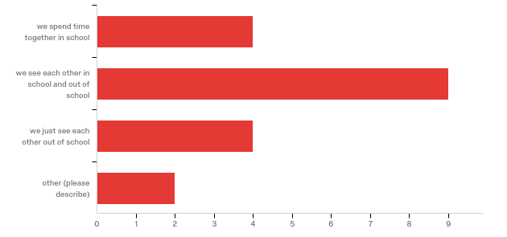

|  |  |  |  |  |  |  |  |
| --- | --- | --- | --- | --- | --- | --- | --- |
| # | Field | Minimum | Maximum | Mean | Std Deviation | Variance | Count |
| 1 | When do you hang out with this friend? (choose one) - Selected Choice | 1.00 | 4.00 | 2.21 | 0.89 | 0.80 | 19 |

|  |  |  |  |
| --- | --- | --- | --- |
| # | Answer | % | Count |
| 1 | we spend time together in school | 21.05% | 4 |
| 2 | we see each other in school and out of school | 47.37% | 9 |
| 3 | we just see each other out of school | 21.05% | 4 |
| 4 | other (please describe) | 10.53% | 2 |
|  | Total | 100% | 19 |

Q88_4_TEXT - other (please describe)

|  |
| --- |
| other (please describe) - Text |
| we don't hang out |
| see in school |

**Q93 - What do you as friends together? (choose all that apply)**

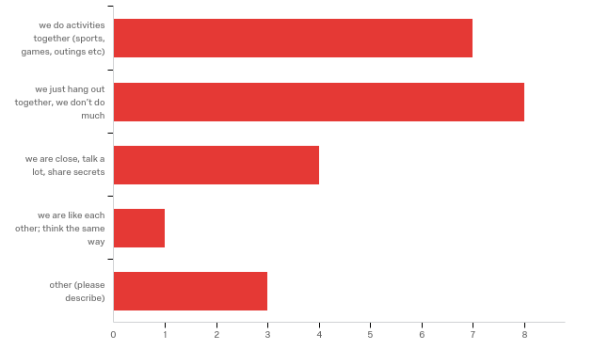

|  |  |  |  |
| --- | --- | --- | --- |
| # | Answer | % | Count |
| 1 | we do activities together (sports, games, outings etc) | 30.43% | 7 |
| 2 | we just hang out together, we don’t do much | 34.78% | 8 |
| 3 | we are close, talk a lot, share secrets | 17.39% | 4 |
| 4 | we are like each other; think the same way | 4.35% | 1 |
| 5 | other (please describe) | 13.04% | 3 |
|  | Total | 100% | 23 |

Q93_5_TEXT - other (please describe)

|  |
| --- |
| other (please describe) - Text |
| we don't |
| classwork |
| in a band |

**Q99 - Does friend #4 vape regularly?**

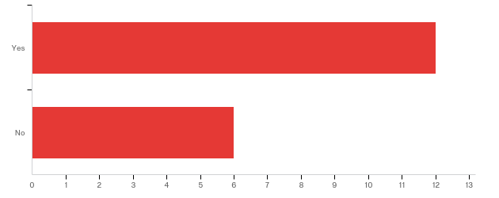

|  |  |  |  |  |  |  |  |
| --- | --- | --- | --- | --- | --- | --- | --- |
| # | Field | Minimum | Maximum | Mean | Std Deviation | Variance | Count |
| 1 | Does friend #4 vape regularly? | 1.00 | 2.00 | 1.33 | 0.47 | 0.22 | 18 |

|  |  |  |  |
| --- | --- | --- | --- |
| # | Answer | % | Count |
| 1 | Yes | 66.67% | 12 |
| 2 | No | 33.33% | 6 |
|  | Total | 100% | 18 |

**Q104 - How does friend #4 get their vape/Juul/e-cigarettes products (oils, device,
etc)? (check one)**

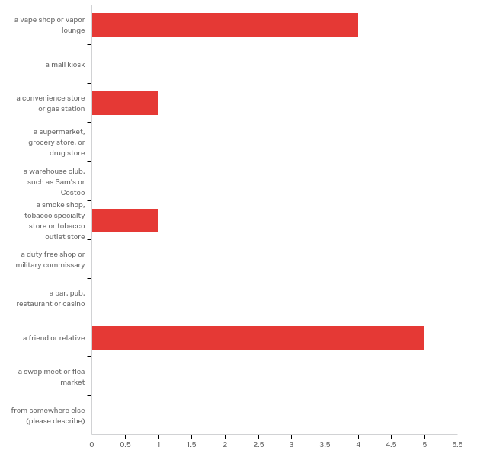

|  |  |  |  |  |  |  |  |
| --- | --- | --- | --- | --- | --- | --- | --- |
| # | Field | Minimum | Maximum | Mean | Std Deviation | Variance | Count |
| 1 | How does friend #4 get their vape/Juul/e-cigarettes products (oils, device, etc)? (check one) - Selected Choice | 1.00 | 9.00 | 5.27 | 3.67 | 13.47 | 11 |

|  |  |  |  |
| --- | --- | --- | --- |
| # | Answer | % | Count |
| 1 | a vape shop or vapor lounge | 36.36% | 4 |
| 2 | a mall kiosk | 0.00% | 0 |
| 3 | a convenience store or gas station | 9.09% | 1 |
| 4 | a supermarket, grocery store, or drug store | 0.00% | 0 |
| 5 | a warehouse club, such as Sam’s or Costco | 0.00% | 0 |
| 6 | a smoke shop, tobacco specialty store or tobacco outlet store | 9.09% | 1 |
| 7 | a duty free shop or military commissary | 0.00% | 0 |
| 8 | a bar, pub, restaurant or casino | 0.00% | 0 |
| 9 | a friend or relative | 45.45% | 5 |
| 10 | a swap meet or flea market | 0.00% | 0 |
| 11 | from somewhere else (please describe) | 0.00% | 0 |
|  | Total | 100% | 11 |

Q104_11_TEXT - from somewhere else (please describe)  
from somewhere else (please describe) - Text

**Q109 - How often does friend #4 give you either the device or supplies,
including oils for you to be able to vape? (choose one)**

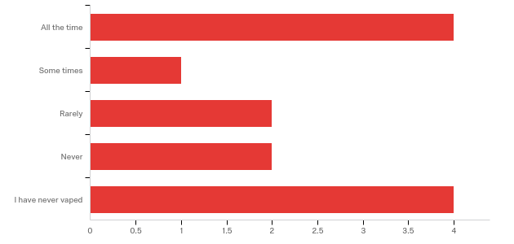

|  |  |  |  |  |  |  |  |
| --- | --- | --- | --- | --- | --- | --- | --- |
| # | Field | Minimum | Maximum | Mean | Std Deviation | Variance | Count |
| 1 | How often does friend #4 give you either the device or supplies, including oils for you to be able to vape? (choose one) | 1.00 | 5.00 | 3.08 | 1.64 | 2.69 | 13 |

|  |  |  |  |
| --- | --- | --- | --- |
| # | Answer | % | Count |
| 1 | All the time | 30.77% | 4 |
| 2 | Some times | 7.69% | 1 |
| 3 | Rarely | 15.38% | 2 |
| 4 | Never | 15.38% | 2 |
| 5 | I have never vaped | 30.77% | 4 |
|  | Total | 100% | 13 |

**Q79 - Which best describes your level of friendship with friend #5? (choose one)**

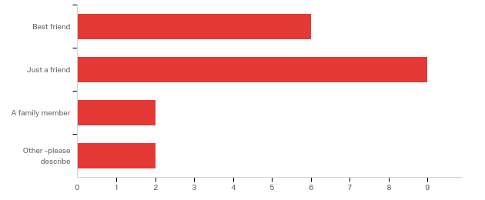

|  |  |  |  |  |  |  |  |
| --- | --- | --- | --- | --- | --- | --- | --- |
| # | Field | Minimum | Maximum | Mean | Std Deviation | Variance | Count |
| 1 | Which best describes your level of friendship with friend #5? (choose one) - Selected Choice | 1.00 | 4.00 | 2.00 | 0.92 | 0.84 | 19 |

|  |  |  |  |
| --- | --- | --- | --- |
| # | Answer | % | Count |
| 1 | Best friend | 31.58% | 6 |
| 2 | Just a friend | 47.37% | 9 |
| 3 | A family member | 10.53% | 2 |
| 4 | Other -please describe | 10.53% | 2 |
|  | Total | 100% | 19 |

Q79_4_TEXT - Other -please describe

|  |
| --- |
| Other -please describe - Text |
| staff |
| classmate |

**Q85 - Is this friend.....(choose one)**

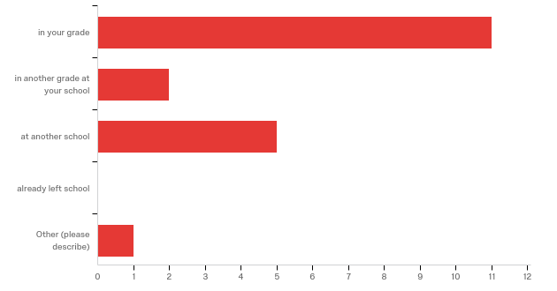

|  |  |  |  |  |  |  |  |
| --- | --- | --- | --- | --- | --- | --- | --- |
| # | Field | Minimum | Maximum | Mean | Std Deviation | Variance | Count |
| 1 | Is this friend.....(choose one) - Selected Choice | 1.00 | 6.00 | 2.16 | 1.56 | 2.45 | 19 |

|  |  |  |  |
| --- | --- | --- | --- |
| # | Answer | % | Count |
| 1 | in your grade | 57.89% | 11 |
| 2 | in another grade at your school | 10.53% | 2 |
| 4 | at another school | 26.32% | 5 |
| 5 | already left school | 0.00% | 0 |
| 6 | Other (please describe) | 5.26% | 1 |
|  | Total | 100% | 19 |

Q85_6_TEXT - Other (please describe)

|  |
| --- |
| Other (please describe) - Text |
| Boys and Girls club |

**Q87 - When do you hang out with this friend? (choose one)**

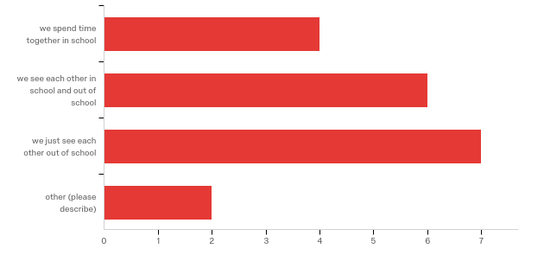

|  |  |  |  |  |  |  |  |
| --- | --- | --- | --- | --- | --- | --- | --- |
| # | Field | Minimum | Maximum | Mean | Std Deviation | Variance | Count |
| 1 | When do you hang out with this friend? (choose one) - Selected Choice | 1.00 | 4.00 | 2.37 | 0.93 | 0.86 | 19 |

|  |  |  |  |
| --- | --- | --- | --- |
| # | Answer | % | Count |
| 1 | we spend time together in school | 21.05% | 4 |
| 2 | we see each other in school and out of school | 31.58% | 6 |
| 3 | we just see each other out of school | 36.84% | 7 |
| 4 | other (please describe) | 10.53% | 2 |
|  | Total | 100% | 19 |

Q87_4_TEXT - other (please describe)

|  |
| --- |
| other (please describe) - Text |
| boys and girls club |
| see in school |

**Q92 - What do you as friends together? (choose all that apply)**

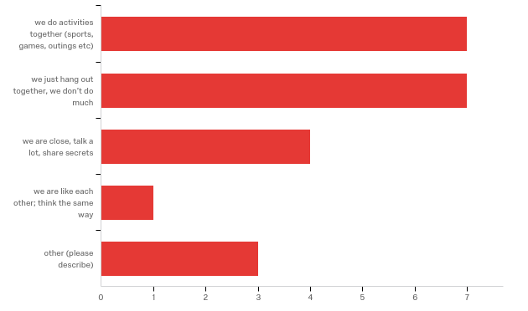

|  |  |  |  |
| --- | --- | --- | --- |
| # | Answer | % | Count |
| 1 | we do activities together (sports, games, outings etc) | 31.82% | 7 |
| 2 | we just hang out together, we don’t do much | 31.82% | 7 |
| 3 | we are close, talk a lot, share secrets | 18.18% | 4 |
| 4 | we are like each other; think the same way | 4.55% | 1 |
| 5 | other (please describe) | 13.64% | 3 |
|  | Total | 100% | 22 |

Q92_5_TEXT - other (please describe)

|  |
| --- |
| other (please describe) - Text |
| smoke |
| boys and girls club |
| classmate |

**Q100 - Does friend #5 vape regularly?**

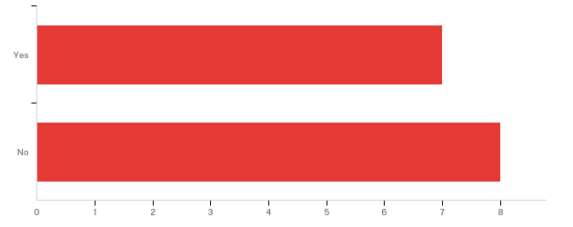

|  |  |  |  |  |  |  |  |
| --- | --- | --- | --- | --- | --- | --- | --- |
| # | Field | Minimum | Maximum | Mean | Std Deviation | Variance | Count |
| 1 | Does friend #5 vape regularly? | 1.00 | 2.00 | 1.53 | 0.50 | 0.25 | 15 |

|  |  |  |  |
| --- | --- | --- | --- |
| # | Answer | % | Count |
| 1 | Yes | 46.67% | 7 |
| 2 | No | 53.33% | 8 |
|  | Total | 100% | 15 |

**Q105 - How does friend #5 get their vape/Juul/e-cigarettes products (oils, device,
etc)? (check one)**

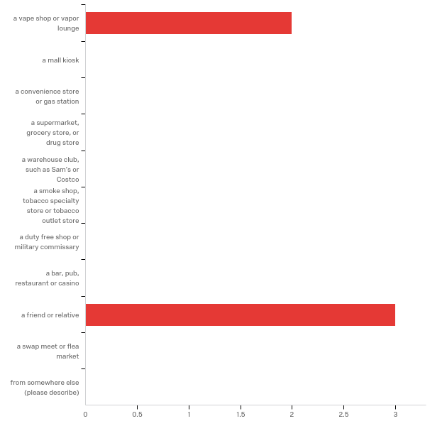

|  |  |  |  |  |  |  |  |
| --- | --- | --- | --- | --- | --- | --- | --- |
| # | Field | Minimum | Maximum | Mean | Std Deviation | Variance | Count |
| 1 | How does friend #5 get their vape/Juul/e-cigarettes products (oils, device, etc)? (check one) - Selected Choice | 1.00 | 9.00 | 5.80 | 3.92 | 15.36 | 5 |

|  |  |  |  |
| --- | --- | --- | --- |
| # | Answer | % | Count |
| 1 | a vape shop or vapor lounge | 40.00% | 2 |
| 2 | a mall kiosk | 0.00% | 0 |
| 3 | a convenience store or gas station | 0.00% | 0 |
| 4 | a supermarket, grocery store, or drug store | 0.00% | 0 |
| 5 | a warehouse club, such as Sam’s or Costco | 0.00% | 0 |
| 6 | a smoke shop, tobacco specialty store or tobacco outlet store | 0.00% | 0 |
| 7 | a duty free shop or military commissary | 0.00% | 0 |
| 8 | a bar, pub, restaurant or casino | 0.00% | 0 |
| 9 | a friend or relative | 60.00% | 3 |
| 10 | a swap meet or flea market | 0.00% | 0 |
| 11 | from somewhere else (please describe) | 0.00% | 0 |
|  | Total | 100% | 5 |

Q105_11_TEXT - from somewhere else (please describe)  
from somewhere else (please describe) - Text

**Q110 - How often does friend #5 give you either the device or supplies,
including oils for you to be able to vape? (choose one)**

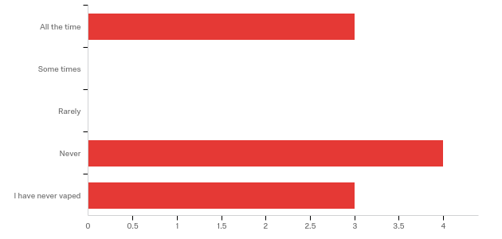

|  |  |  |  |  |  |  |  |
| --- | --- | --- | --- | --- | --- | --- | --- |
| # | Field | Minimum | Maximum | Mean | Std Deviation | Variance | Count |
| 1 | How often does friend #5 give you either the device or supplies, including oils for you to be able to vape? (choose one) | 1.00 | 5.00 | 3.40 | 1.62 | 2.64 | 10 |

|  |  |  |  |
| --- | --- | --- | --- |
| # | Answer | % | Count |
| 1 | All the time | 30.00% | 3 |
| 2 | Some times | 0.00% | 0 |
| 3 | Rarely | 0.00% | 0 |
| 4 | Never | 40.00% | 4 |
| 5 | I have never vaped | 30.00% | 3 |
|  | Total | 100% | 10 |

**Q80 - Which best describes your level of friendship with friend #6? (choose one)**

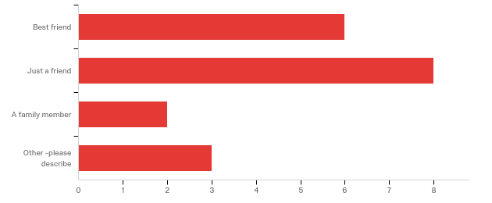

|  |  |  |  |  |  |  |  |
| --- | --- | --- | --- | --- | --- | --- | --- |
| # | Field | Minimum | Maximum | Mean | Std Deviation | Variance | Count |
| 1 | Which best describes your level of friendship with friend #6? (choose one) - Selected Choice | 1.00 | 4.00 | 2.11 | 1.02 | 1.04 | 19 |

|  |  |  |  |
| --- | --- | --- | --- |
| # | Answer | % | Count |
| 1 | Best friend | 31.58% | 6 |
| 2 | Just a friend | 42.11% | 8 |
| 3 | A family member | 10.53% | 2 |
| 4 | Other -please describe | 15.79% | 3 |
|  | Total | 100% | 19 |

Q80_4_TEXT - Other -please describe

|  |
| --- |
| Other -please describe - Text |
| relationship |
| classmate |
| girlfriend |

**Q83 - Is this friend.....(choose one)**

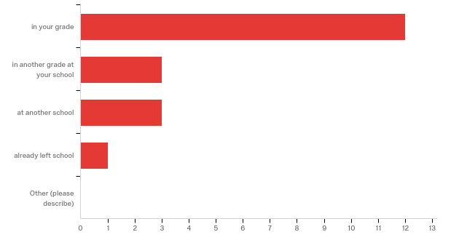

|  |  |  |  |  |  |  |  |
| --- | --- | --- | --- | --- | --- | --- | --- |
| # | Field | Minimum | Maximum | Mean | Std Deviation | Variance | Count |
| 1 | Is this friend.....(choose one) - Selected Choice | 1.00 | 5.00 | 1.84 | 1.31 | 1.71 | 19 |

|  |  |  |  |
| --- | --- | --- | --- |
| # | Answer | % | Count |
| 1 | in your grade | 63.16% | 12 |
| 2 | in another grade at your school | 15.79% | 3 |
| 4 | at another school | 15.79% | 3 |
| 5 | already left school | 5.26% | 1 |
| 6 | Other (please describe) | 0.00% | 0 |
|  | Total | 100% | 19 |

Q83_6_TEXT - Other (please describe)  
Other (please describe) - Text

**Q86 - When do you hang out with this friend? (choose one)**

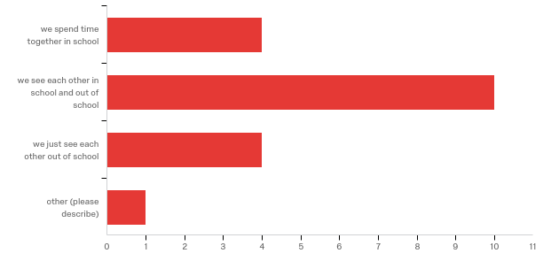

|  |  |  |  |  |  |  |  |
| --- | --- | --- | --- | --- | --- | --- | --- |
| # | Field | Minimum | Maximum | Mean | Std Deviation | Variance | Count |
| 1 | When do you hang out with this friend? (choose one) - Selected Choice | 1.00 | 4.00 | 2.11 | 0.79 | 0.62 | 19 |

|  |  |  |  |
| --- | --- | --- | --- |
| # | Answer | % | Count |
| 1 | we spend time together in school | 21.05% | 4 |
| 2 | we see each other in school and out of school | 52.63% | 10 |
| 3 | we just see each other out of school | 21.05% | 4 |
| 4 | other (please describe) | 5.26% | 1 |
|  | Total | 100% | 19 |

Q86_4_TEXT - other (please describe)

|  |
| --- |
| other (please describe) - Text |
| see in school |

**Q91 - What do you as friends together? (choose all that apply)**

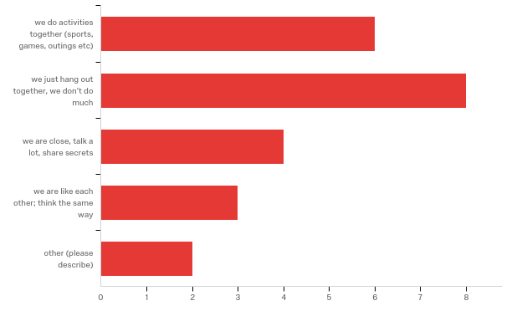

|  |  |  |  |
| --- | --- | --- | --- |
| # | Answer | % | Count |
| 1 | we do activities together (sports, games, outings etc) | 26.09% | 6 |
| 2 | we just hang out together, we don’t do much | 34.78% | 8 |
| 3 | we are close, talk a lot, share secrets | 17.39% | 4 |
| 4 | we are like each other; think the same way | 13.04% | 3 |
| 5 | other (please describe) | 8.70% | 2 |
|  | Total | 100% | 23 |

Q91_5_TEXT - other (please describe)

|  |
| --- |
| other (please describe) - Text |
| smoke |
| classwork |

**Q101 - Does friend #6 vape regularly?**

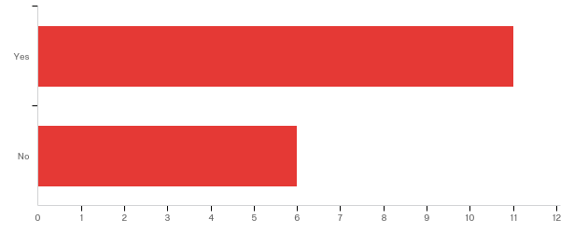

|  |  |  |  |  |  |  |  |
| --- | --- | --- | --- | --- | --- | --- | --- |
| # | Field | Minimum | Maximum | Mean | Std Deviation | Variance | Count |
| 1 | Does friend #6 vape regularly? | 1.00 | 2.00 | 1.35 | 0.48 | 0.23 | 17 |

|  |  |  |  |
| --- | --- | --- | --- |
| # | Answer | % | Count |
| 1 | Yes | 64.71% | 11 |
| 2 | No | 35.29% | 6 |
|  | Total | 100% | 17 |

**Q106 - How does friend #6 get their vape/Juul/e-cigarettes products (oils, device,
etc)? (check one)**

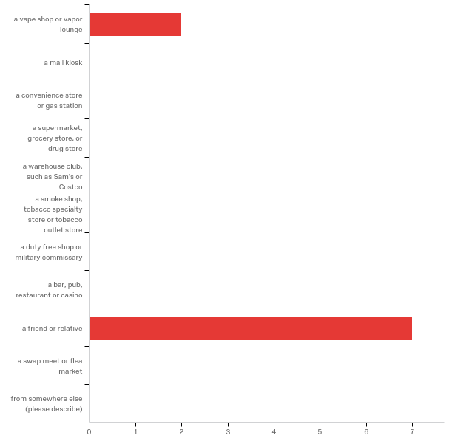

|  |  |  |  |  |  |  |  |
| --- | --- | --- | --- | --- | --- | --- | --- |
| # | Field | Minimum | Maximum | Mean | Std Deviation | Variance | Count |
| 1 | How does friend #6 get their vape/Juul/e-cigarettes products (oils, device, etc)? (check one) - Selected Choice | 1.00 | 9.00 | 7.22 | 3.33 | 11.06 | 9 |

|  |  |  |  |
| --- | --- | --- | --- |
| # | Answer | % | Count |
| 1 | a vape shop or vapor lounge | 22.22% | 2 |
| 2 | a mall kiosk | 0.00% | 0 |
| 3 | a convenience store or gas station | 0.00% | 0 |
| 4 | a supermarket, grocery store, or drug store | 0.00% | 0 |
| 5 | a warehouse club, such as Sam’s or Costco | 0.00% | 0 |
| 6 | a smoke shop, tobacco specialty store or tobacco outlet store | 0.00% | 0 |
| 7 | a duty free shop or military commissary | 0.00% | 0 |
| 8 | a bar, pub, restaurant or casino | 0.00% | 0 |
| 9 | a friend or relative | 77.78% | 7 |
| 10 | a swap meet or flea market | 0.00% | 0 |
| 11 | from somewhere else (please describe) | 0.00% | 0 |
|  | Total | 100% | 9 |

Q106_11_TEXT - from somewhere else (please describe)  
from somewhere else (please describe) - Text

**Q111 - How often does friend #6 give you either the device or supplies,
including oils for you to be able to vape? (choose one)**

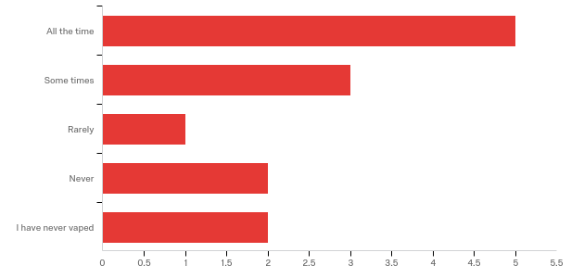

|  |  |  |  |  |  |  |  |
| --- | --- | --- | --- | --- | --- | --- | --- |
| # | Field | Minimum | Maximum | Mean | Std Deviation | Variance | Count |
| 1 | How often does friend #6 give you either the device or supplies, including oils for you to be able to vape? (choose one) | 1.00 | 5.00 | 2.46 | 1.50 | 2.25 | 13 |

|  |  |  |  |
| --- | --- | --- | --- |
| # | Answer | % | Count |
| 1 | All the time | 38.46% | 5 |
| 2 | Some times | 23.08% | 3 |
| 3 | Rarely | 7.69% | 1 |
| 4 | Never | 15.38% | 2 |
| 5 | I have never vaped | 15.38% | 2 |
|  | Total | 100% | 13 |